Colegio Santa María de Maipú
Departamento

CORRECCIÓN Guía de autoaprendizaje N°1 de inglés 7° básico
Name:______________________________________________________ Date: ______________
OA: CONSOLIDAR EL USO DE ADJETIVOS POSESIVOS Y APLICARLOS EN FRASES DE USO FRECUENTE ADEMAS DE UTILIZAR DE MANERA CORRECTA PALABRAS PARA REALIZAR PREGUNTAS EN TIEMPO PRESENTE Y PASADO.
Possessive Adjectives: watch the ppt “possessive adjectives” and write the correct word in the boxes below.
my your his her its our their

1. The boy likes___his___ school.
2. Mary sees __her____ mother every day.
3. My teachers bring__their__ children to our place on Saturdays.
4. The cat eats ____ its______ food quickly.
5. I often forget __my_____ key.
6. The men always bring ___their_wives to the party.
7. Mr Adams teaches____his___ class in the morning.
8. She likes to give presents to _her__grandchildren.
9.They never do ___their_______homework.
10.Ali sometimes wear ____her_____green t-shirt.
11.We love _____our____school.
12.Ayse and Ahmet play with ____their__sisters.
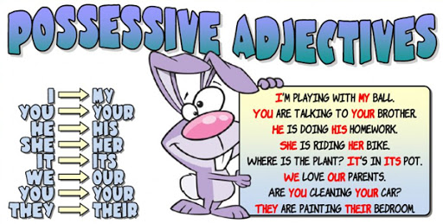
13.You always wear ___your__uniform at school.
14. I rarely walk to __my_school.
15.We eat __our__lunch at 12 a.m.
16.The bird always sleeps in _its_ nest.
17.She always forget __her___books in the cupboard.
18.He often speaks to ____his________friends.
19.They close ____their_____books.
20.Where is (I) ____my____ book?
21.Here is (we) ____our________ teacher.
22.She goes to school with (she) __her___ brother.
23.(They)___Their____father works in a car factory.
24.(You)___Your _____ laptop is very expensive.
25.(He )____His____favourite hobby is tennis.
26.(I) ____My___husband and I want to go to Paris.
27.(It) ___Its_____name is Bobby
28.(They)__Their ______names are Joseph and Jacobs.
29.(I)__My______teacher loves me
30.(We) ____Our______school is very nice.

Remember!!!

Question words
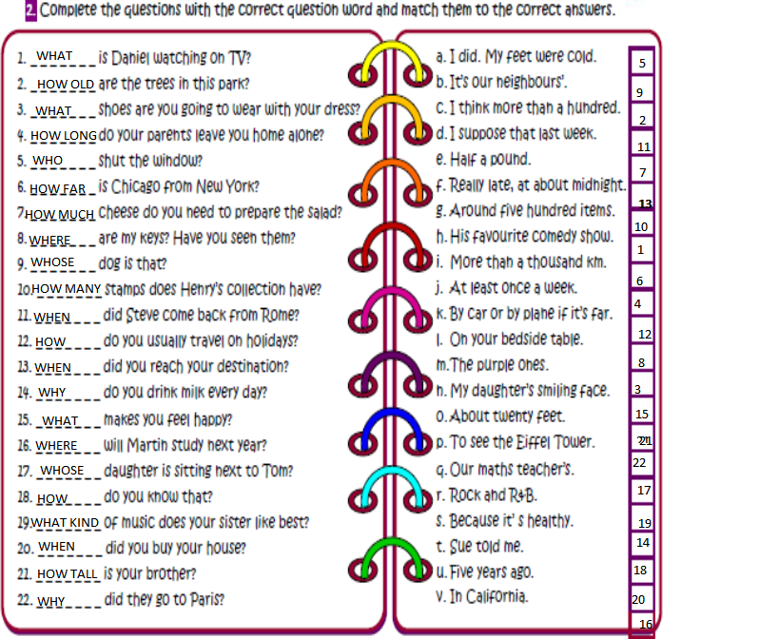

Nota: Cada respuesta correcta suma 1 punto, el puntaje total de la guía es de 52 puntos.
Menos de 40 puntos: Debes rehacer la guía y volver a reforzar los contenidos que se te hicieron más difíciles, busca apoyo en tu texto de estudio o en internet, esto será de gran ayuda para progresar.
41 puntos o más: FELICITACIONES! Lograste el objetivo de la guía puedes pasar sin problemas a la guía de autoaprendizaje n°2.
- _ _ _ _ _ _ _ is Daniel watching on TV?
- _ _ _ _ _ _ _ are the trees in this park?
- _ _ _ _ _ _ _ shoes are you going to wear with your dress?
- _ _ _ _ _ _ _ do your parents leave you home alone?
- _ _ _ _ _ _ _ shut the window?
- _ _ _ _ _ _ _ is Chicago from New York?
- _ _ _ _ _ _ _ cheese do you need to prepare the salad?
- _ _ _ _ _ _ _ are my keys? Have you seen them?
- _ _ _ _ _ _ _ dog is that?
10. _ _ _ _ _ _ _ stamps does Henry’s collection have?
11. _ _ _ _ _ _ _ did Steve come back from Rome?
12. _ _ _ _ _ _ _ do you usually travel on holidays?
13. _ _ _ _ _ _ _ did you reach your destination?
14. _ _ _ _ _ _ _ do you drink milk every day?
15. _ _ _ _ _ _ _ makes you feel happy?
16. _ _ _ _ _ _ _ will Martin study next year?
17. _ _ _ _ _ _ _ daughter is sitting next to Tom?
18. _ _ _ _ _ _ _ do you know that?
19. _ _ _ _ _ _ _ of music does your sister like best?
20. _ _ _ _ _ _ _ did you buy your house?
21. _ _ _ _ _ _ _ is your brother?
22. _ _ _ _ _ _ _ did they go to Paris?
- _ _ _ _ _ _ _ is Daniel watching on TV?
- _ _ _ _ _ _ _ are the trees in this park?
- _ _ _ _ _ _ _ shoes are you going to wear with your dress?
- _ _ _ _ _ _ _ do your parents leave you home alone?
- _ _ _ _ _ _ _ shut the window?
- _ _ _ _ _ _ _ is Chicago from New York?
- _ _ _ _ _ _ _ cheese do you need to prepare the salad?
- _ _ _ _ _ _ _ are my keys? Have you seen them?
- _ _ _ _ _ _ _ dog is that?
10. _ _ _ _ _ _ _ stamps does Henry’s collection have?
11. _ _ _ _ _ _ _ did Steve come back from Rome?
12. _ _ _ _ _ _ _ do you usually travel on holidays?
13. _ _ _ _ _ _ _ did you reach your destination?
14. _ _ _ _ _ _ _ do you drink milk every day?
15. _ _ _ _ _ _ _ makes you feel happy?
16. _ _ _ _ _ _ _ will Martin study next year?
17. _ _ _ _ _ _ _ daughter is sitting next to Tom?
18. _ _ _ _ _ _ _ do you know that?
19. _ _ _ _ _ _ _ of music does your sister like best?
20. _ _ _ _ _ _ _ did you buy your house?
21. _ _ _ _ _ _ _ is your brother?
22. _ _ _ _ _ _ _ did they go to Paris?
- _ _ _ _ _ _ _ is Daniel watching on TV?
- _ _ _ _ _ _ _ are the trees in this park?
- _ _ _ _ _ _ _ shoes are you going to wear with your dress?
- _ _ _ _ _ _ _ do your parents leave you home alone?
- _ _ _ _ _ _ _ shut the window?
- _ _ _ _ _ _ _ is Chicago from New York?
- _ _ _ _ _ _ _ cheese do you need to prepare the salad?
- _ _ _ _ _ _ _ are my keys? Have you seen them?
- _ _ _ _ _ _ _ dog is that?
10. _ _ _ _ _ _ _ stamps does Henry’s collection have?
11. _ _ _ _ _ _ _ did Steve come back from Rome?
12. _ _ _ _ _ _ _ do you usually travel on holidays?
13. _ _ _ _ _ _ _ did you reach your destination?
14. _ _ _ _ _ _ _ do you drink milk every day?
15. _ _ _ _ _ _ _ makes you feel happy?
16. _ _ _ _ _ _ _ will Martin study next year?
17. _ _ _ _ _ _ _ daughter is sitting next to Tom?
18. _ _ _ _ _ _ _ do you know that?
19. _ _ _ _ _ _ _ of music does your sister like best?
20. _ _ _ _ _ _ _ did you buy your house?
21. _ _ _ _ _ _ _ is your brother?
22. _ _ _ _ _ _ _ did they go to Paris?
- _ _ _ _ _ _ _ is Daniel watching on TV?
- _ _ _ _ _ _ _ are the trees in this park?
- _ _ _ _ _ _ _ shoes are you going to wear with your dress?
- _ _ _ _ _ _ _ do your parents leave you home alone?
- _ _ _ _ _ _ _ shut the window?
- _ _ _ _ _ _ _ is Chicago from New York?
- _ _ _ _ _ _ _ cheese do you need to prepare the salad?
- _ _ _ _ _ _ _ are my keys? Have you seen them?
- _ _ _ _ _ _ _ dog is that?
10. _ _ _ _ _ _ _ stamps does Henry’s collection have?
11. _ _ _ _ _ _ _ did Steve come back from Rome?
12. _ _ _ _ _ _ _ do you usually travel on holidays?
13. _ _ _ _ _ _ _ did you reach your destination?
14. _ _ _ _ _ _ _ do you drink milk every day?
15. _ _ _ _ _ _ _ makes you feel happy?
16. _ _ _ _ _ _ _ will Martin study next year?
17. _ _ _ _ _ _ _ daughter is sitting next to Tom?
18. _ _ _ _ _ _ _ do you know that?
19. _ _ _ _ _ _ _ of music does your sister like best?
20. _ _ _ _ _ _ _ did you buy your house?
21. _ _ _ _ _ _ _ is your brother?
22. _ _ _ _ _ _ _ did they go to Paris?

