Guía de autoaprendizaje N°1 Inglés 3° Básico

NAME:_....................................................... 3° Básico………. DATE……………………
OA: Al finalizar esta guía el estudiante lograra identificar el vocabulario previamente visto. (Use of can and can´t, emotions and actions with -ing)
Estimados apoderados,
Esta actividad debe ser guiada e impresa (una hoja por cada actividad, NO doble hoja). Los alumnos deben leer atentamente la instrucción y posteriormente identificar el vocabulario.
Saludos cordiales, Miss Constanza Urrutia.

I.- Write down the correct use of can and can´t.
Escribe el uso correcto de can (puedo) y can´t (no puedo).
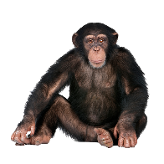
- Monkey ________________ climb.
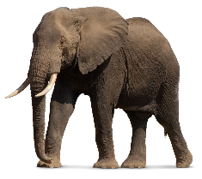
- Lion ___________________talk.
- Elephant ________________jump
- Giraffe _________________run

II.- Observe the images, cut and paste the emotions into the correct faces.
Observar las imagines, recorta y pega las emociones en los rostros correctos.

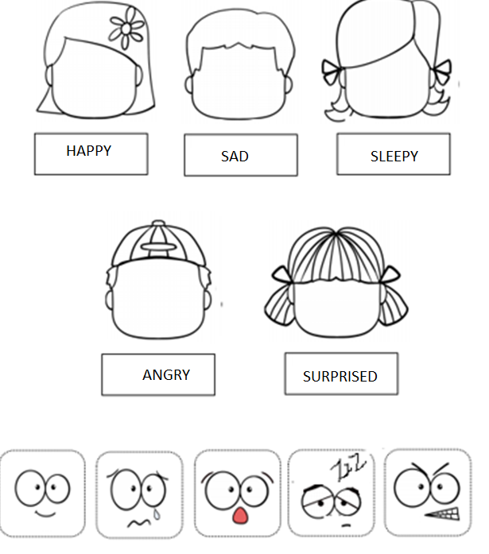

III.- Choose the correct alternative.
Elige la alternative correcta.

She is __________________  A) Playing  B) Drinking  C) Singing | 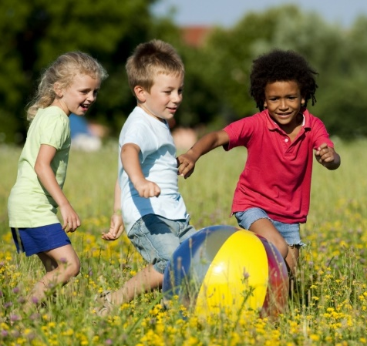  They are ________________  A) Crying  B) Playing  C) Singing
He is ___________________  A) Running  B) Playing  C) Crying | He is ___________________  A) Drinking  B) Singing  C) Dancing

IV.- Where does he / she work?
¿Dónde el / ella trabaja?

- A doctor works in a _____________________________

- A chef works in a _______________________________

- A teacher works in a ____________________________

- A police officer works in a _______________________

