Colegio Santa María de Maipú

Departamento

Guía de autoaprendizaje de inglés 7° básico

Name:______________________________________________________ Date: ______________

OA: CONSOLIDAR EL USO DE ADJETIVOS POSESIVOS Y APLICARLOS EN FRASES DE USO FRECUENTE ADEMAS DE UTILIZAR DE MANERA CORRECTA PALABRAS PARA REALIZAR PREGUNTAS EN TIEMPO PRESENTE Y PASADO.

***Possessive Adjectives: watch the ppt “possessive adjectives” and write the correct word in the boxes below***.

**my your his her its our their**

1. ***The boy*** likes________________ school.

2. ***Mary*** sees __________ mother every day.

3***. My teachers*** bring___________ children to our place on Saturdays.

4. ***The cat*** eats _____________ food quickly.

5. ***I*** often forget _____________ key.

6. ***The men*** always bring ______________wives to the party.

7. ***Mr Adams*** teaches_______________ class in the morning.

8. ***She*** likes to give presents to ___________________grandchildren.

9.***They*** never do _______________homework.

10.***Ali*** sometimes wear ____________green t-shirt.

11.***We*** love ________________school.

12.***Ayse and Ahmet*** play with __________________ sisters.

13.***You*** always wear ______________uniform at school.

14. ***I*** rarely walk to ___________________school.

15.***We*** eat _______________lunch at 12 a.m.

16.***The bird*** always sleeps in _________________ nest.

17.***She*** always forget _________________books in the cupboard.

18.***He*** often speaks to ________________friends.

19.***They*** close _____________books.

20.Where is **(I)** ___________ book?

21.Here is **(we)** _______________ teacher.

22.She goes to school with **(she)** _____________ brother.

23.**(They)**_________father works in a car factory.

24**.(You)**_____________ laptop is very expensive.

25**.(He** )______________favourite hobby is tennis.

26**.(I)** __________________husband and I want to go to Paris.

**27.(It)** _____________________name is Bobby

28.(**The**y)____________names are Joseph and Jacobs.

**29.(I)**________________teacher loves me ☺

30**.(We)** ________________school is very nice.

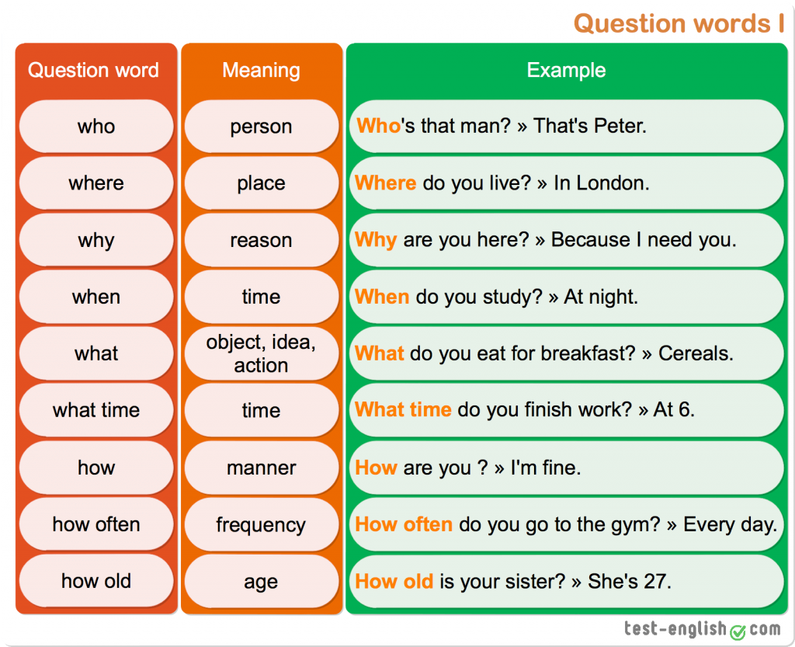

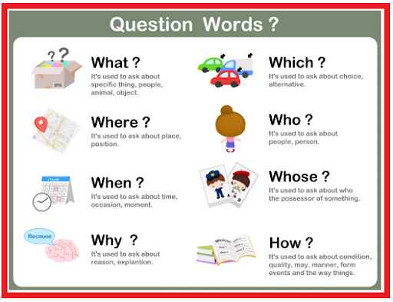

***Question words***

