Colegio Santa María de Maipú
Departamento de Inglés

Guía de autoaprendizaje inglés 4° básico

Name:______________________________________________________________ Date: ______________
OA: Practicar el uso de pronombres personales y el verbo have got/ has got.

A.- Replace using the correct personal pronoun.
1.- Mary:___she_
2.- Richard:___HE_______
3.- Bob and Tim: ___THEY___________
4.- The desk:__IT___________
5.- Romina and I :___WE_________
6.- The dog: ____IT________
7.- Susan: ______SHE_________

B.- Complete the sentence using the corresponding pronoun.
1.- ___HE_____is reading a book (Willy)
2.- ___IT_______ is green (The cup)
3.- ____IT_______ is on the wall. (The clock)
4.- __WE_______ are watching tv (My mother and I)
5.- ___THEY_____ are in the garden. (Tom and Louis)

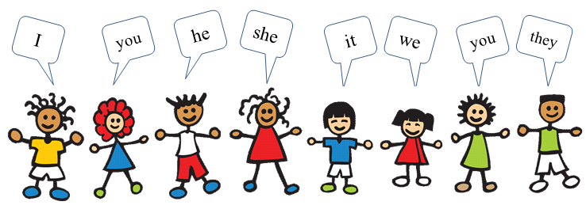

C.- Complete using have got or has got:
1. She _has got____ a new umbrella.
2. He __ has got _ a calculator.
3. They _have got_ wonderful bikes.
4. I __ have got __ a parrot.
5. Andrew __ has got __ a dog.
6. They _ have got _ many books.
7. Sandra _ has got __ a present.
8. We _ have got _ three balloons.
9. You _ have got a bag.
10. I _ have got a guitar.
11. They _ have got sunglasses.
12. Laura __ has got a clock.

