Colegio Santa María de Maipú
Departamento de Inglés

Guía de autoaprendizaje inglés 4° básico

Name:______________________________________________________________ Date: ______________
OA: Practicar el uso de pronombres personales y el verbo have got/ has got.

A.- Replace using the correct personal pronoun.
1.- Mary:___she_
2.- Richard:____________
3.- Bob and Tim: ______________
4.- The desk:_____________
5.- Romina and I :____________
6.- The dog: ____________
7.- Susan: _______________

B.- Complete the sentence using the corresponding pronoun.
1.- ___________is reading a book (Willy)
2.- ___________ is green (The cup)
3.- ___________ is on the wall. (The clock)
4.- ___________ are watching tv (My mother and I)
5.- ___________ are in the garden. (Tom and Louis)

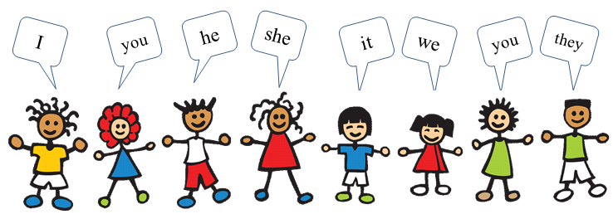

C.- Complete using have got or has got:
1. She ______ a new umbrella.
2. He ______ a calculator.
3. They ______ wonderful bikes.
4. I ______ a parrot.
5. Andrew ______ a dog.
6. They _______ many books.
7. Sandra ______ a present.
8. We ______ three balloons.
9. You ______ a bag.
10. I ______ a guitar.
11. They ______ sunglasses.
12. Laura ______ a clock.

