**GUÍA DE AUTOAPRENDIZAJE Nº7 TECNOLOGÍA**

**Iº MEDIO**

|  |
| --- |
|  |

|  |
| --- |
|  |

|  |
| --- |
|  |



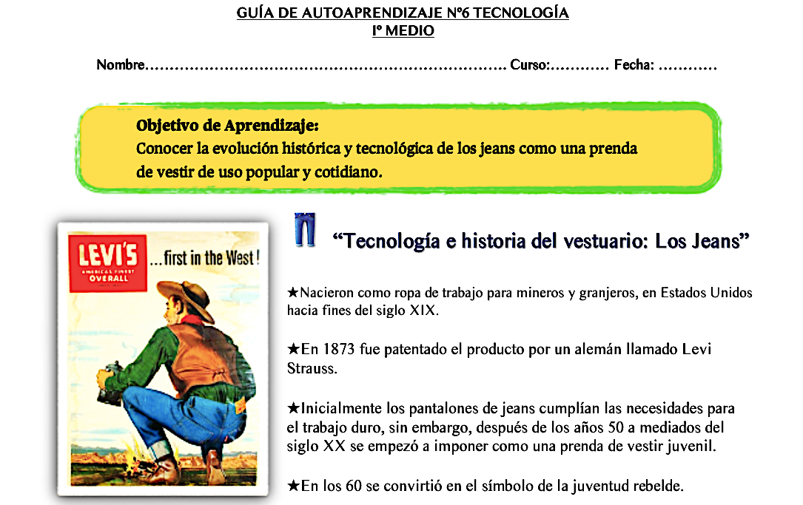

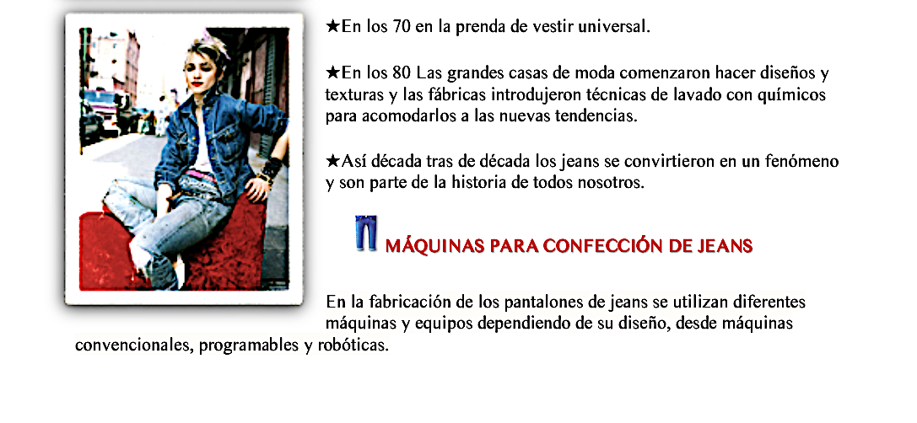

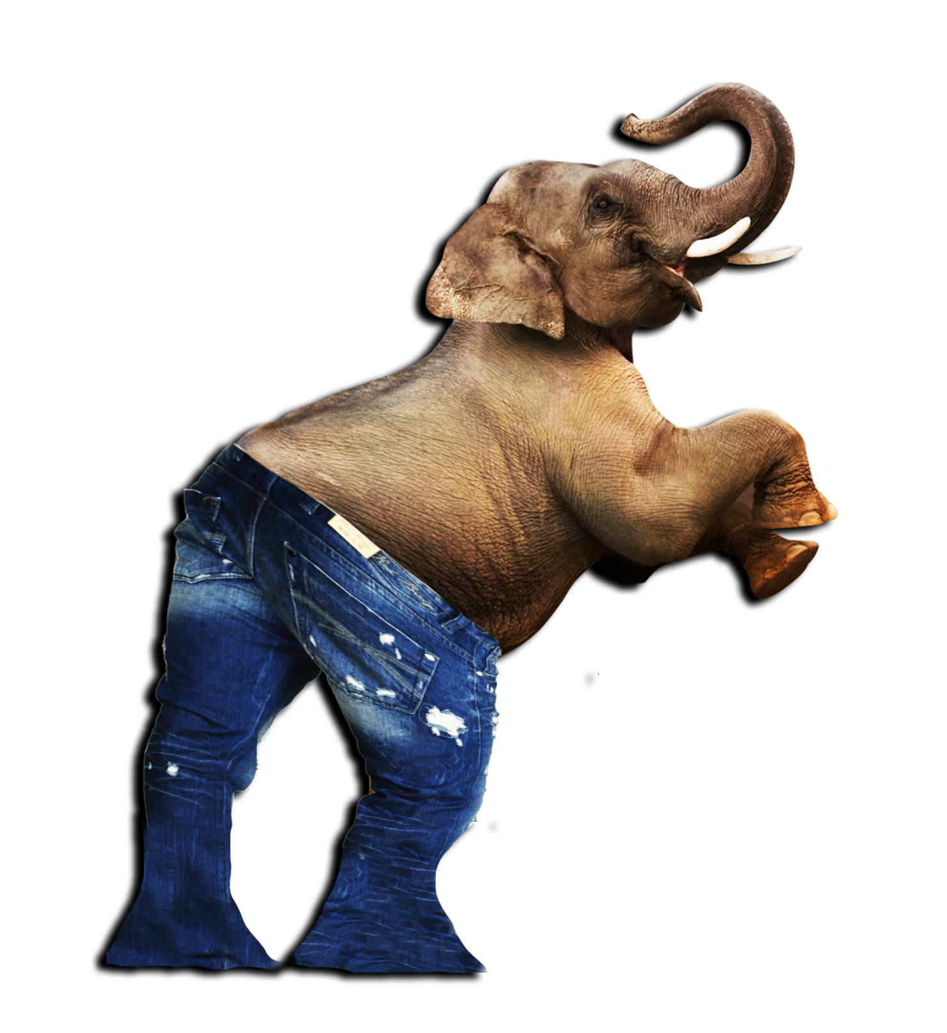

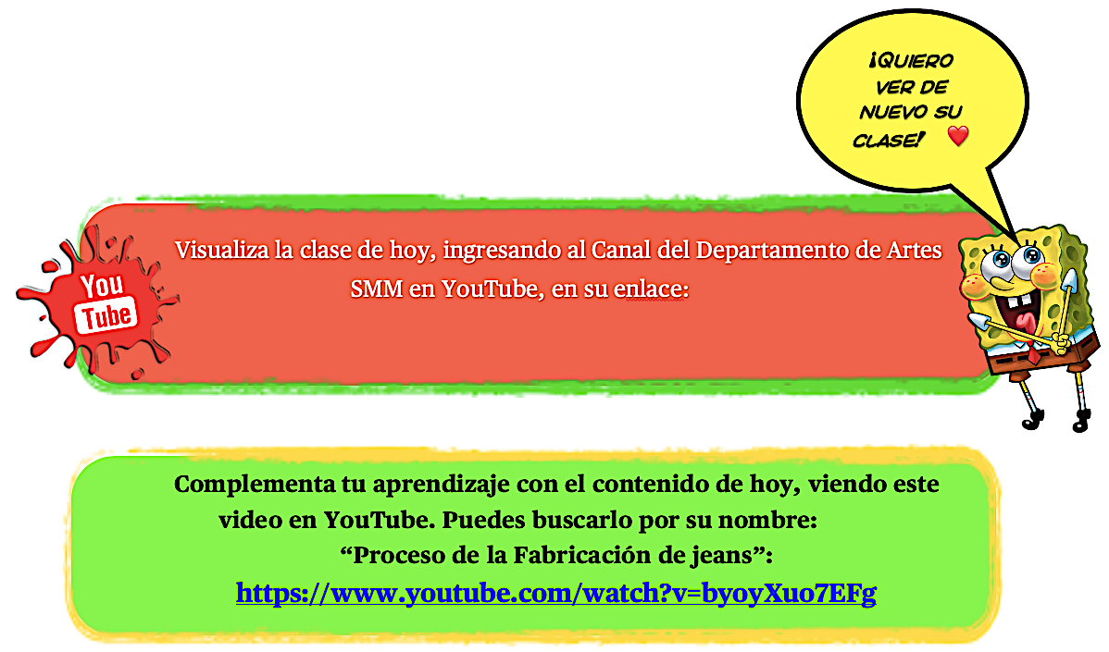

[**https://www.youtube.com/watch?v=Up81y2Xrriw&t=22s**](https://www.youtube.com/watch?v=Up81y2Xrriw&t=22s)







  
  
  



  
  
  
  
  



  
  
  
  
  



  
  
  





  
  
  
  
  
  
  