Na
Colegio Santa María de Maipú
Departamento de Inglés
RETROALIMENTACIÓN
Semana 1 de Junio

OA: TO UNDERSTAND VOCABULARY RELATED TO HEALTHY HABITS AND UNHEALTHY HABITS.

1.- Circle the healthy habits and underline the unhealthy habits shown below.

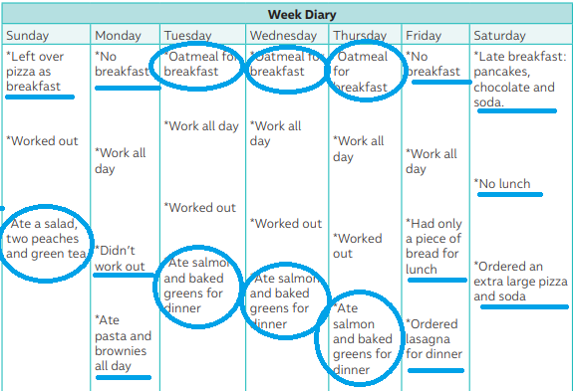

- Healthy habits:
• Ate a salad.
• Two peaches and green tea.
• Oatmeal for breakfast.
• Ate salmon and baked greens for dinner.

Unhealthy habits:
• Left over pizza as breakfast.
• No breakfast.
• Ate pasta and brownies all day.
• Had only a piece of bread for lunch.
• Ordered lasagna for dinner.
• Ordered an extra large pizza and soda.
• No lunch.
• Late breakfast: pancakes, chocolate and soda.

