ANSWER SHEET
GUIA DE AUTOAPRENDIZAJE Nº11 INGLÉS
IVº MEDIO

Nombre_______________________________________ Curso:_______ Fecha: _______
En esta guía el estudiante estará practicando las habilidades que el idioma inglés requiere para mantener una continuidad en su proceso de aprendizaje.

I.- WATCH THE FOLLOWING VIDEO AND USE YOUR NOTEBOOK WHEN YOU ARE TOLD TO.
(CLICK ON THE IMAGE BELOW AND THE VIDEO WILL PLAY AUTOMATICALLY)
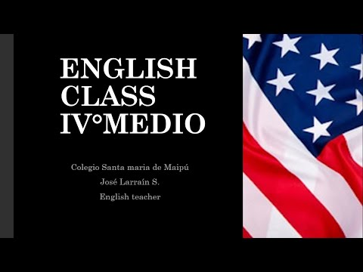
- DON’T FORGET TO COMPLETE THE ACTIVITIES PROVIDED ON THE VIDEO ABOVE, USE YOUR NOTEBOOK TO KEEP RECORDS OF THEM.

II.-COMPLETE THESE SENTENCES WITH THE PROPER QUESTION TAG.

1. She’s from a small town in China, ISN’T SHE?
2. They aren’t on their way already, ARE THEY?
3. We’re late again, AREN’T WE?
4. I’m not the person with the tickets, AM I?
5. Julie isn’t an accountant, IS SHE?
6. The weather is really bad today, ISN’T IT?
7. He’s very handsome, ISN’T HE?
8. They aren’t in Mumbai at the moment, ARE THEY?
9. You aren’t from Brazil, ARE YOU?
10. John’s a very good student, ISN’T HE?
11. I like chocolate very much, DON’T I?
12. She doesn’t work in a hotel, DOES SHE?
13. They need some new clothes, DON’T THEY?
14. We live in a tiny flat, DON’T WE?
15. She studies very hard every night,DOESN’T SHE?
16. David and Julie don’t take Chinese classes, DO THEY?
17. I often come home late, DON’T I?
18. You don’t like spicy food, DO YOU?
19. She doesn’t cook very often, DOES SHE?
20. We don’t watch much TV, DO WE?

*note: you can find out the right answers in the link provided in the instructions.

CONTACT INFO: ING.CUARTOMEDIO.SMM@GMAIL.COM

