ANSWER SHEET
GUÍA DE AUTOAPRENDIZAJE Nº11 INGLÉS
IIº MEDIO

Nombre_______________________________________ Curso:______ Fecha: _______
En esta guía el estudiante estará practicando las habilidades que el idioma inglés requiere para mantener una continuidad en su proceso de aprendizaje.

I.- WATCH THE FOLLOWING VIDEO AND USE YOUR NOTEBOOK WHEN YOU ARE TOLD TO.
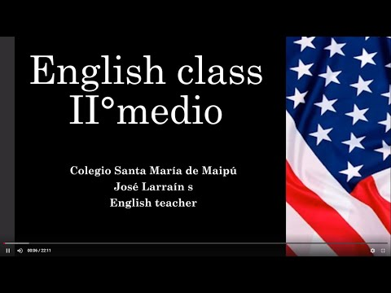
(CLICK ON THE IMAGE BELOW AND THE VIDEO WILL PLAY AUTOMATICALLY)

II.-COMPLETE THE SENTENCES USING ANY – SOME.

1.- Have you got ____ANY___ tomatoes?
2.- There are ____SOME___ exercise books on the floor.
3.- Did you get the ketchup? No, they didn't have ____ANY___ .
4.- You should eat __SOME_____ fresh fruit.
5.- We had to wait for ____SOME___ minutes.

III.-COMPLETE THE SENTENCES USING A-AN– SOME.

1.- I have ___A____ good idea.
2.- That's ___AN____ interesting job!
3.- They have found ___SOME____ gold in that old mine.
4.- Do the Smiths have ___A____ yellow van?
5.- Look! He's having ____SOME___ water.

IV.-COMPLETE THE SENTENCES USING MUCH – MANY.

1.- There isn't ___MUCH____ milk left in the fridge.
2.- You shouldn't eat so ___MANY____ sweets.
3.- My friend doesn't eat ____MUCH___ fruit.
4.- They don't know ____MUCH___ about the history of their country.
5.- I don't have ____MUCH___ time to practise basketball.

*note: you can find out the right answers in the link provided in the instructions.

CONTACT INFO: ingles.ii.smm@gmail.com

