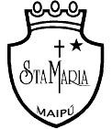
Na
Colegio Santa María de Maipú
Departamento de Inglés
WORKSHEET N° 11 SEMANA 29 junio de 2020
OA: Identify healthy/ unhealthy vocabulary and expressing agreement and disagreement.
Name:___________________________________________________ Class: __________
