FEEDBACK: Guía de autoaprendizaje Inglés 2° Básico

NAME:_............................................................................................................................... 2° Básico…………..

Objetivo de aprendizaje:
OA3: Identifican vocabulario escuchado de partes de la casa y muebles.
OA13: • Copian frases de acuerdo a un modelo
Instrucciones:
-Observar el video de la plataforma de youtube sobre los contenidos de esta semana.
-Con la ayuda de un adulto, realizar esta guía en un lugar tranquilo y con todos tus materiales (estuche, cuaderno).
YOU CAN DO IT!

I.-

I.- Listen, Cut and paste the objects of the house (escuchar, cortar y pegar los objectos de la casa)

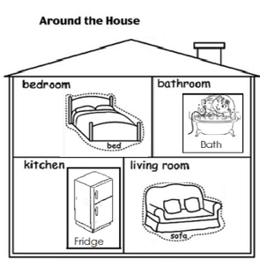

II.- Look at the pictures and write down 3 sentences using there is or there are. (Mirar las imágenes y escribir 3 oraciones usando there is o there are).

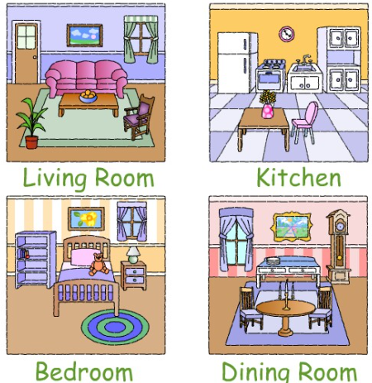

- Example: There is 1 sofa in the living room

- There is 1 lamp in the bedroom

- There is one bed

- There is 1 fridge in the kitchen

