GUIA DE AUTOAPRENDIZAJE Nº11 INGLÉS
I° MEDIO
UNIT 2: KEEP ON LEARNING
ANSWERS

Al final de esta guía se espera que el estudiante desarrolle los objetivos de aprendizaje relacionados con:

- Aplicar vocabulario temático de la unidad.
- Reforzar el uso de comparativos y superlativos, especialmente, sus excepciones.
(OA1-0A14)

- Listening Spot: Watch the video, listen and write 4 words that you don’t know about education, and their meaning (definition).

(Example, you can choose the words you want to)
- Distance learning: a way of studying over the internet, like online lessons.
- To give feedback: to offer guidance on a student’s work.
- To learn something by heart: to memorize something.
- To sit an exam: to take an exam

- Vocabulary Spot: Match every concept from the box where it belongs.

Drop out Cheat on Get a degree Lifelong

1. Melissa can’t do this anymore. She says she’s going to DROP OUT English, is too difficult for her.
2. The studies of LIFELONG education must be redefined and expanded.
3. Hey! It is not right to try to CHEAT ON your final exam!
4. The teacher went to college 5 years ago to GET A DEGREE about education.

- Complete with the comparatives and Superlatives that corresponds. Remember:
In Comparatives we add the adjective (example: old) and “er” and “than” He’s older than me.
In Superlatives we add “the” when necessary and the adjective (example: young) and “est” He’s the youngest in the family.

I’m from a very big family. I’ve got ten brothers and sisters and they’re all (1) OLDER THAN (old) me – I’m (2) ……………………… (young). We play in a band. Andy is the singer because he’s got (3) ……………………… (good) voice. He’s also (4) ……………………… (confident) person and loves being on stage. I’m (5) ……………………… (shy) the others and I always hide myself at the back!
Tanya sings with Andy. Joe is (6) ……………………… (funny) brother and he makes us laugh when we’re tired or nervous. Jack is (7) ……………………… (serious) – perhaps because he’s the oldest. From all the families, mine is (8) ………………. (good) all the families all over the world!

1. Older than
2. The youngest
3. The best
4. The most confident

5. shier than
6. the funniest
7. the most serious
8. better than

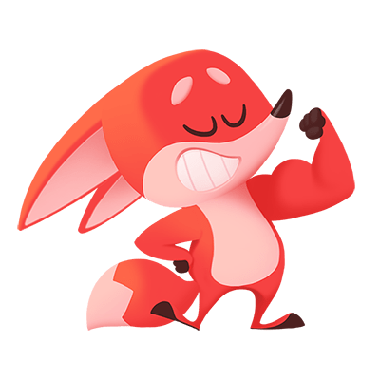
Nota:
Espero las respuestas correctas te hayan servido!
Trabaja con tu texto escolar y revisa cada pregunta detenidamente.
Si al final de la guía lograste 2 items correctos, felicitaciones! Si solo lograste 1 ítem correcto, tu puedes!
Estas a punto de alcanzar el objetivo! Pone atención en los errores para la próxima y revisa el link de la clase en: https://youtu.be/JRp28JBq5mM
You can do it!

