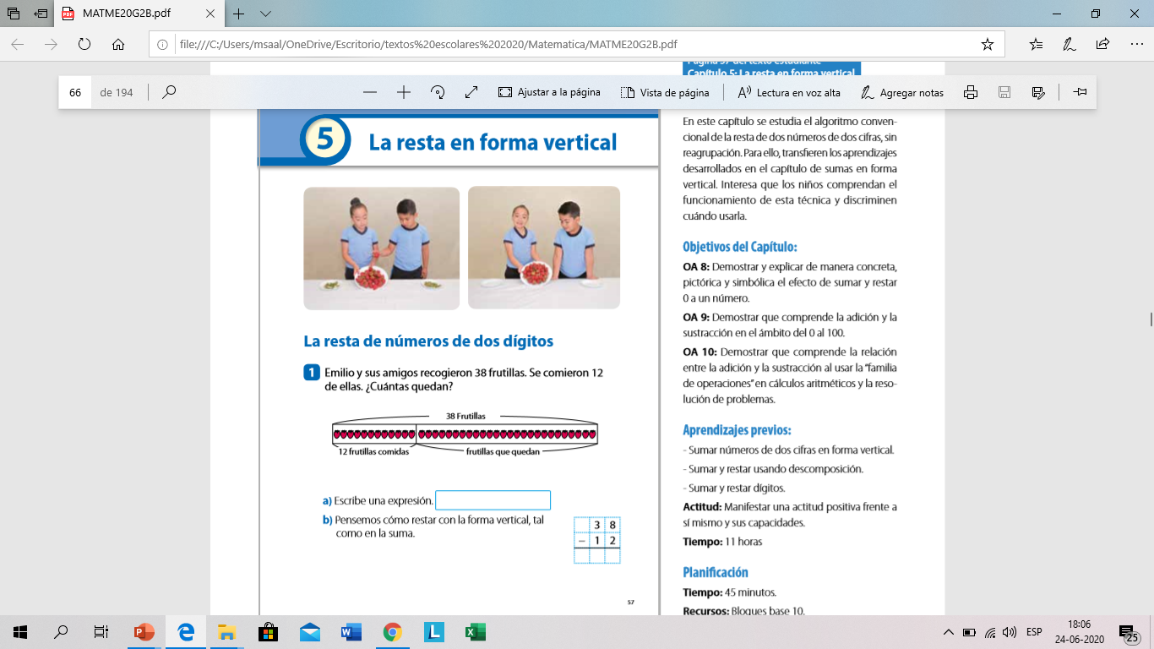

38 - 12

3 8

* 1 2

________

2 6