GUIA DE AUTOAPRENDIZAJE N°13 INGLÉS
8° BÁSICO
UNIT 3: GOING PLACES

Class: https://youtu.be/sX3ouOQ9tGg

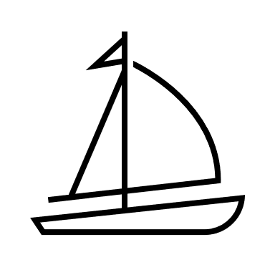
Al final de esta guía se espera que el estudiante desarrolle los objetivos de aprendizaje relacionados con:

- Aplicar vocabulario temático nuevo de la unidad y expresiones relacionadas con viajar.
(OA8-0A9)

In this worksheet you will apply the contents seen on the lesson.

Vocabulary used to travel
You can need different objects to travel. On this worksheet we will learn about them. Also important vocabulary used when you travel to a different country.

- Vocabulary Spot: What is it? Guess the vocabulary of the following word search.

A. Boarding ticket
B. Luggage
C. Passport
D. ID card
E. Cash
F. Wallet
G. Camera
H. Map
I. Flight Assistant
J. Airport

- Expressions: Match the following expressions with the pictures below.

Catch (a bus, a train) Get (a plane, a bus)
Get off (a train, a bus) Go (on holidays, a train)
_____________________ ___________________

______________________ ____________________

Pay attention to the lesson on the youtube link,
read carefully and use your textbook.
Remember to write down your answers
to ask in our weekly online lessons!
You can do it! 😊

