ANSWER SHEET
GUÍA DE AUTOAPRENDIZAJE Nº14 INGLÉS
IIIº MEDIO

Nombre_______________________________________ Curso:_______ Fecha: _______

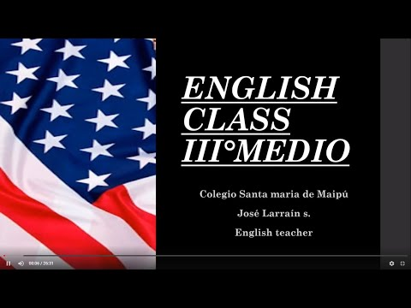
I.- WATCH THE FOLLOWING VIDEO AND USE YOUR NOTEBOOK WHEN YOU ARE TOLD TO.

(CLICK ON THE IMAGE BELOW AND THE VIDEO WILL PLAY AUTOMATICALLY)
- DON’T FORGET TO COMPLETE THE ACTIVITIES PROVIDED ON THE VIDEO ABOVE, USE YOUR NOTEBOOK TO KEEP RECORDS OF THEM.

II.- COMPLETE THE FOLLOWING CHART WITH THE MISSING INFORMATIOMN FROM THE VIDEO ABOVE.
Affirmative | Negative | Interrogative
I have been playing videogames lately. | I haven’t been playing videogames lately. | Have I been playing videogames lately?
I have been running during the lockdown. | I haven’t been running during the lockdown. | Have I been running during the lockdown?
My son has been doing a lot of homework for school | My son hasn’t been doing a lot of homework for school | Has my son been doing a lot of homework for school?

.

III.-LISTEN AND ANSWER THE FOLLOWING QUESTIONS. (https://www.esl-lab.com/easy/party-time/)

1.- Who is visiting Jori for the weekend?
A.- her sister
B.- her brother Bob
C.- her best friend

2.- Carol is wearing _____.
A.- a green jacket
B.- a green blouse
C.- a red sweater

3.- Carol is ______.
A.- reliable
B.- timid
C.- sociable

4.- Bob is wearing _____.
A.- a flashy suit jacket
B.- blue jeans
C.- a green tie

5.- Jori knows Bob because _____.
A.- they met at a party two months ago
B.- she is taking karate lessons from him.
C.- they work together in the same office

*note: you can find out the right answers in the link provided in the instructions.

CONTACT INFO: ING.TERCEROMEDIO.SMM@GMAIL.COM

