ANSWERSHEET
GUÍA DE AUTOAPRENDIZAJE Nº13 INGLÉS
IIº MEDIO

Nombre_______________________________________ Curso:______ Fecha: _______
En esta guía el estudiante estará practicando las habilidades que el idioma inglés requiere para mantener una continuidad en su proceso de aprendizaje.

I.- WATCH THE FOLLOWING VIDEO AND USE YOUR NOTEBOOK WHEN YOU ARE TOLD TO.
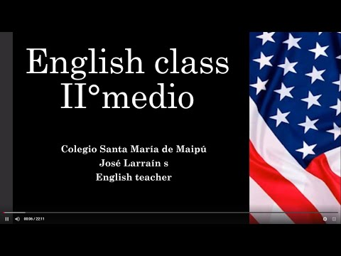
(CLICK ON THE IMAGE BELOW AND THE VIDEO WILL PLAY AUTOMATICALLY)

II.- WRITE THE NAME OF THE PERSON REGARDING THE AREA IN WHICH THEY HAVE OUTSTOOD. AND WRITE 5 MORE PEOPLE YOU CONSIDERED AS OUTSTANDING.

- (Marilyn Monroe, John Lennon, The Weeknd, Mother Teresa, Elon Musk, Martin Luther King, Leonardo DiCaprio, Pelé, Albert Einstein)

POLITICS | ARTS | SCIENCE | RELIGION
MARTIN LUTHER KING | MARILYN MONROE | ELON MUSK | MATHER TERESA
 | JOHN LENNON | ALBERT EINSTEIN
 | THE WEEKND
 | LEONARDO DICAPRIO

III.-CHOOSE AN OUTSTANDING PERSON AND COMPLETE THE INFORMATION REQUIERED.

IV.-LISTEN AND ANSWER THE FOLLOWING QUESTIONS.

1.- The people are __________ right now.
a.- at a park
b.- in a hotel
c.- at the airport

2.- Sara is the man's _______.
a.- mother
b.- spouse
c.- sister

3.- The man has _____ dollars on him.
a.- ten
b.- fifteen
c.- five

4.- He lost ________ at the casino last time.
a.- $1,700
b.- $1,500
c.- $1,200

5.- The man and woman are probably going to _______ at the end of the conversation.
a.- go sightseeing in town
b.- shop for new clothing
c.- buy food for their friends

*note: you can find out the right answers in the link provided in the instructions.

CONTACT INFO: ingles.ii.smm@gmail.com

