GUÍA DE AUTOAPRENDIZAJE Nº14 INGLÉS
IIº MEDIO

Nombre_______________________________________ Curso:______ Fecha: _______
En esta guía el estudiante estará practicando las habilidades que el idioma inglés requiere para mantener una continuidad en su proceso de aprendizaje.

I.- WATCH THE FOLLOWING VIDEO AND USE YOUR NOTEBOOK WHEN YOU ARE TOLD TO.
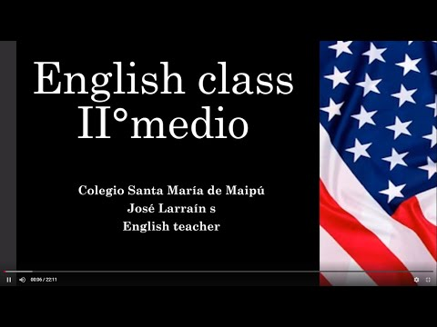
(CLICK ON THE IMAGE BELOW AND THE VIDEO WILL PLAY AUTOMATICALLY)

II.- WRITE SENTENCES ABOUT THESE PEOPLE USING ALTHOUGH AND THOUGH.
People | Sentences
Marilyn Monroe
John Lennon
The Weeknd
Elon Musk

III.-LISTEN AND ANSWER THE FOLLOWING QUESTIONS. (https://www.esl-lab.com/easy/party-time/)

1.- Who is visiting Jori for the weekend?
A.- her sister
B.- her brother Bob
C.- her best friend

2.- Carol is wearing _____.
A.- a green jacket
B.- a green blouse
C.- a red sweater

3.- Carol is ______.
A.- reliable
B.- timid
C.- sociable

4.- Bob is wearing _____.
A.- a flashy suit jacket
B.- blue jeans
C.- a green tie

5.- Jori knows Bob because _____.
A.- they met at a party two months ago
B.- she is taking karate lessons from him
C.- they work together in the same office

*note: you can find out the right answers in the link provided in the instructions.

CONTACT INFO: ingles.ii.smm@gmail.com

