ANSWERSHEET
GUIA DE AUTOAPRENDIZAJE Nº13 INGLÉS
IVº MEDIO

Nombre_______________________________________ Curso:_______ Fecha: _______
En esta guía el estudiante estará practicando las habilidades que el idioma inglés requiere para mantener una continuidad en su proceso de aprendizaje.

I.- WATCH THE FOLLOWING VIDEO AND USE YOUR NOTEBOOK WHEN YOU ARE TOLD TO.
(CLICK ON THE IMAGE BELOW AND THE VIDEO WILL PLAY AUTOMATICALLY)
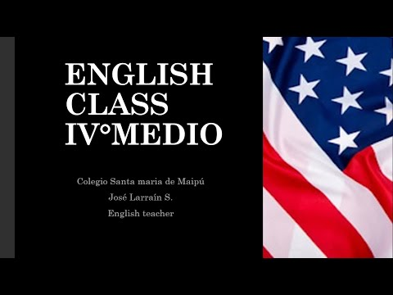
DON’T FORGET TO COMPLETE THE ACTIVITIES PROVIDED ON THE VIDEO ABOVE, USE YOUR NOTEBOOK TO KEEP RECORDS OF THEM.
II.-COMPLETE THIS CHART WITH THE MISSING INFO FROM THE VIDEO.
CONNECTOR | SENTENCES
OR | Do you want tea or coffee?
WHILE | I was watching youtube videos while cooking.
SO | I went home early so Im not sleepy now.
WITH | I went out with my friends
AND | She bought a chocolate bar and a chips bag.
WHETHER | I don’t know whether I buy pizza or Mc Donald’s.

III.-LISTEN AND ANSWER THE FOLLOWING QUESTIONS.

1.- The people are __________ right now.
a.- at a park
b.- in a hotel
c.- at the airport

2.- Sara is the man's _______.
a.- mother
b.- spouse
c.- sister

3.- The man has _____ dollars on him.
a.- ten
b.- fifteen
c.- five

4.- He lost ________ at the casino last time.
a.- $1,700
b.- $1,500
c.- $1,200

5.- The man and woman are probably going to _______ at the end of the conversation.
a.- go sightseeing in town
b.- shop for new clothing
c.- buy food for their friends

*note: you can find out the right answers in the link provided in the instructions.

CONTACT INFO: ING.CUARTOMEDIO.SMM@GMAIL.COM

