GUIA DE AUTOAPRENDIZAJE Nº14 INGLÉS
IVº MEDIO

Nombre_______________________________________ Curso:_______ Fecha: _______
En esta guía el estudiante estará practicando las habilidades que el idioma inglés requiere para mantener una continuidad en su proceso de aprendizaje.

I.- WATCH THE FOLLOWING VIDEO AND USE YOUR NOTEBOOK WHEN YOU ARE TOLD TO.
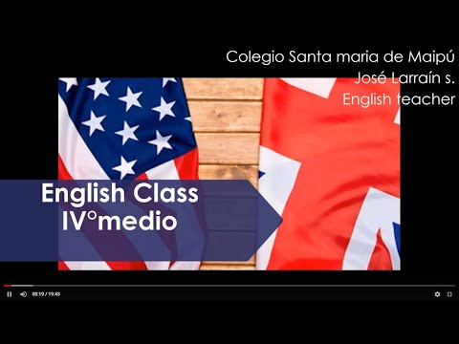

(CLICK ON THE IMAGE BELOW AND THE VIDEO WILL PLAY AUTOMATICALLY)

DON’T FORGET TO COMPLETE THE ACTIVITIES PROVIDED ON THE VIDEO ABOVE, USE YOUR NOTEBOOK TO KEEP RECORDS OF THEM.

II.-COMPLETE THIS CHART WITH THE MISSING INFO FROM THE VIDEO.

1. If I _______ (be) you, I ________ _________ (get) a new job.

2. If he _______ __________ (be) younger, he ________ (travel) more.

3. If we ________ (not / be) friends, I _________________ (be) angry with you.

4. If I __________ (have) enough money, I ________ (buy) a big house.

5. If she ________ ________ (not / be) always so late, she _________________ (be) promoted.

6. If we ________ _________ (win) the lottery, we ________ _________ (travel) the world.

III.-LISTEN AND ANSWER THE FOLLOWING QUESTIONS. (https://www.esl-lab.com/easy/party-time/)

1.- Who is visiting Jori for the weekend?
A.- her sister
B.- her brother Bob
C.- her best friend

2.- Carol is wearing _____.
A.- a green jacket
B.- a green blouse
C.- a red sweater

3.- Carol is ______.
A.- reliable
B.- timid
C.- sociable

4.- Bob is wearing _____.
A.- a flashy suit jacket
B.- blue jeans
C.- a green tie

5.- Jori knows Bob because _____.
A.- they met at a party two months ago
B.- she is taking karate lessons from him.
C.- they work together in the same office

IV.- Go to the following link and answer.

https://docs.google.com/forms/d/e/1FAIpQLSctglkHFe6eNPPCZNvJFFU3J1U538Z-vadiABGhD-3zDRnITA/viewform?usp=sf_link

CONTACT INFO: ING.CUARTOMEDIO.SMM@GMAIL.COM

