Guía de autoaprendizaje Inglés 2° Básico

NAME:_............................................................................................................................ 2° Básico…………..
Objetivo de aprendizaje:
OA6: Identifican vocabulario sobre ocupaciones y lugares de trabajo.
OA13: Completan oraciones de acuerdo a una imagen y con apoyo de palabras.
Instrucciones:
-Observar el video de la plataforma de youtube sobre los contenidos de esta semana.
-Con la ayuda de un adulto, realizar esta guía en un lugar tranquilo y con todos tus materiales (estuche, cuaderno).
YOU CAN DO IT!

I.-

Unit 3 “I want to be a….. ”
I.- Look at the images and write down the correct profession and places of work. (mirar las imagines y escribir la profesión correcta y el lugar de trabajo)

E.X:

POLICE OFFICER
POLICE OFFICER
PLACES OF WORK
PROFESSIONS
POLICE STATION

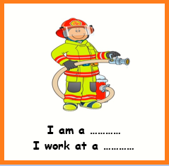
FIRE STATION
FIRE FIGHTER
SCHOOL
TEACHER
HOSPITAL
DOCTOR

II.- Read and answer the questions.(leer y responder las preguntas)
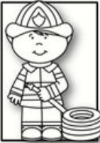
FIREFIGHTERS
Firefighter’s works in a fire station. They save people, animals and buildings. They use a fire truck with a lot of water to do their job. Firefighters use specials masks.

True or False
- Firefighters works in a fire station ___T_______
- Firefighters save only people ___F_______
- Firefighters have cars with water ___F_______

What do firefighters do?
Fire fighters save people, animals and buildings

