Guía de autoaprendizaje Inglés 1° Básico

NAME:_...................................................................................................................... 1°Básico…………..
Objetivo de aprendizaje:
OA13:Copian y unen palabras sobre el clima y prendas de vestir.
Instrucciones:
-Observar el video de la plataforma de youtube sobre los contenidos de esta semana.
-Con la ayuda de un adulto, realizar esta guía en un lugar tranquilo y con todos tus materiales (estuche, cuaderno).
YOU CAN DO IT!

Unit 3 : What´s the weather like today?

- Match the word with the correct image. ( unir con la imagen correcta)

-Rainy

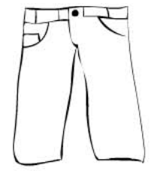
-Pant
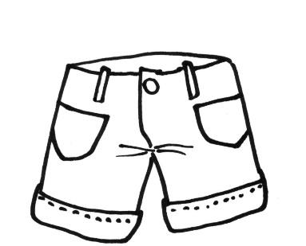

- Sunny

- Short

2.- Listen and complete the sentences with the words in the box. (escuchar y completar la oración con las palabras del recuadro)
Cloudy - Rainy - Sunny

The weather is __________________________

The weather is __________________________

The weather is___________________________

3.- Listen the sentence and color. (Escuchar la oración y pintar)

-She has a pink dress and purple shoes.  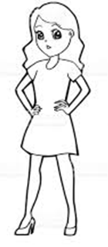 | -He has a green jacket and red pants.  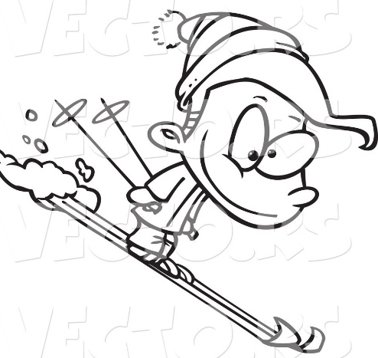

Link capsula educativa:
https://www.youtube.com/watch?v=7WyzAxIBAiQ&feature=youtu.be

