FEEDBACK

NAME:_...................................................................................................................... 1°Básico…………..
Objetivo de aprendizaje:
OA6: Identifican descripción de ropa: black shoes.
OA13: Completan letras de palabras de acuerdo a imagen
Instrucciones:
-Observar el video de la plataforma de youtube sobre los contenidos de esta semana.
-Con la ayuda de un adulto, realizar esta guía en un lugar tranquilo y con todos tus materiales (estuche, cuaderno).
YOU CAN DO IT!

Unit 3 : What´s the weather like today?
- An orange short:
- A blue T- shirt:
- A Brown jacket
- A pink dress
I.- Read and paint. (leer y pintar).

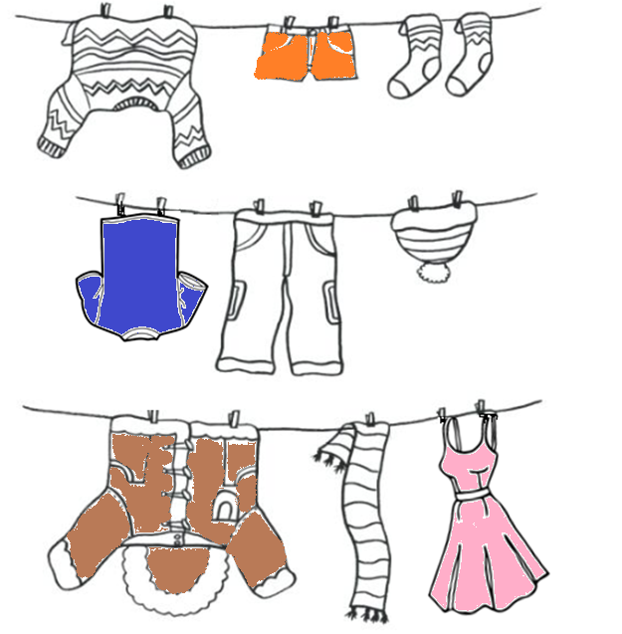

II.- Complete and write the missing letters.
A - E – 0 - I

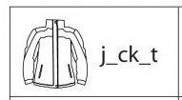

E
A

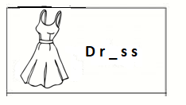

E

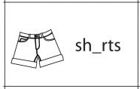

O

Link capsula educativa:
https://www.youtube.com/watch?v=VbA9rpvZGss&feature=youtu.be

