FEEDBACK

NAME:_.......................................................................................................................... 3° Básico…………..
Objetivo de aprendizaje:
OA6: Identifican palabras y expresiones relacionadas con la casa y sus habitaciones.
OA13: Escriben los nombres de algunas habitaciones de la casa y de algunos objetos con el apoyo de imágenes.
Instrucciones:
-Observar el video de la plataforma de youtube sobre los contenidos de esta semana.
-Con la ayuda de un adulto, realizar esta guía en un lugar tranquilo y con todos tus materiales (estuche, cuaderno).
YOU CAN DO IT!

I.-

Unit 3 “My house ”
I.- Match the image with the correct word. (Unir la imagen con la palabra correcta)
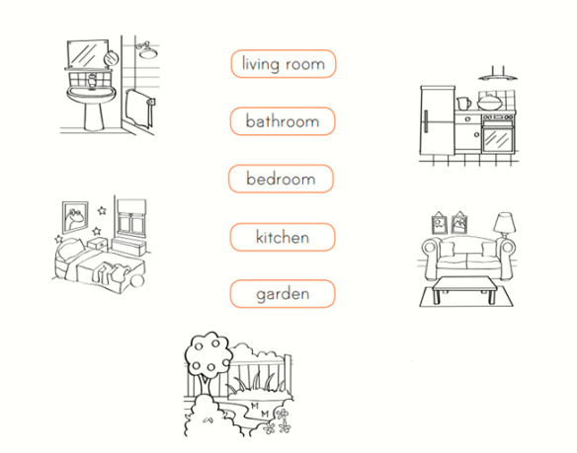

II.- Find the errors and correct them. If the sentence is correct just go to the next one. (encontrar los errores y corregirlos. Si la oración esta correcta pasa a la siguiente)

a) There is three lamps ___There ARE three lamps______________
b) There are two beds ____There are two beds________________
c) There are one table ____There IS one table__________________

III.- Read the text and answer with true or false (leer el texto y responder con verdadero o falso)

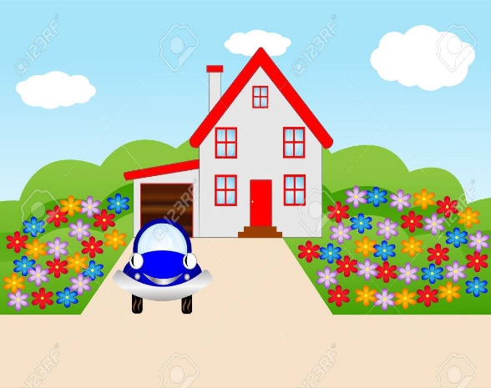
My house
My name is Mario. I have a happy family. We live in a big house. In the house, there is one kitchen to cook food. There is one fridge full of food. There is one dining room. There is one table and there are four chairs in my dining room. There is a living room to watch TV. There are three sofas in the living room. There is one big garden. There are three bedrooms to sleep. One bedroom for me and my brother. There are two beds and two lamps in my bedroom.

- There are three fridges. ___F_____
- There is one kitchen ___T_____
- In the dinning room there are three chairs __F_____
- There is one sofa in the living room ___F_____
- There are three bedrooms ____T_____

Link capsula educative:
https://www.youtube.com/watch?v=_n907wnW5mk

