GUIA DE AUTOAPRENDIZAJE Nº14 INGLÉS
I° MEDIO
UNIT 3: THE ARTS

Class: https://youtu.be/PB5Nc8h-wcQ

Al final de esta guía se espera que el estudiante desarrolle los
objetivos de aprendizaje relacionados con:
- Aplicar vocabulario temático de la unidad.
(OA1-0A8)

The Arts
On the world of art, we can have a lot of different people who practice it, of course on different forms and types, for example you can have people working on literature, comics, paintings, dancing, photography, sculptures and so on. On this worksheet we are going to review these people.

- Identify the following pictures and name them with the corresponding artists.

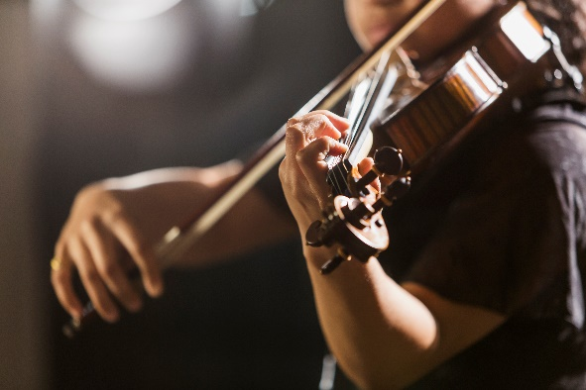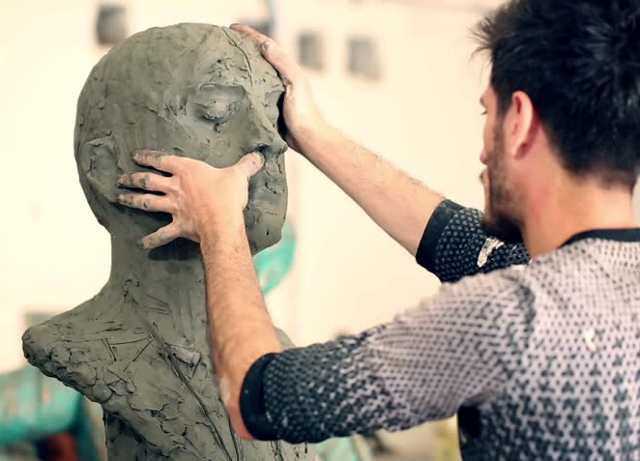
______________________________ ______________________________

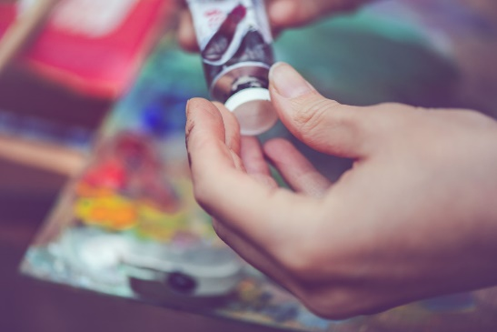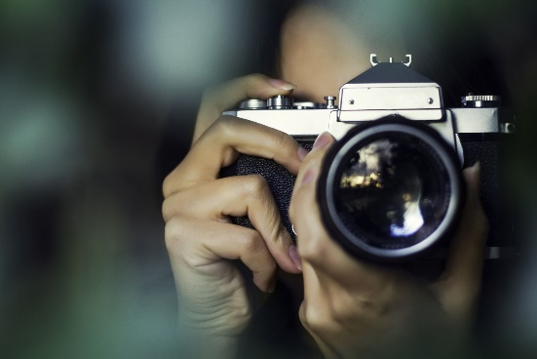
______________________________ ______________________________

II. Complete the following sentences with the artists you can see on the box.

Dancer Artists Actor Writer Sculptor Musicians

- The _____________ supervised the placement of his newest sculpture in the garden.
- The _____________ of my favorite book said that the movie is coming on 2022!
- Madonna is one of the most amazing _____________ of all the times, she has won a lot of different awards.
- There is an art gallery across the street, a lot of _____________ will show their work tomorrow.
- Did you watch the Superbowl? Shakira is an excellent _____________ along with Jennifer Lopez.
- I didn’t like the play, the main _____________ was faking the sad scenes! It is the worst theater play of my life.

Pay attention to the lesson on the youtube link,
read carefully and use your textbook.
Remember to write down your answers
to ask in our weekly online lessons!
You can do it!

