GUIA DE AUTOAPRENDIZAJE Nº14 INGLÉS
I° MEDIO
UNIT 3: THE ARTS
ANSWER KEY

Class: https://youtu.be/PB5Nc8h-wcQ

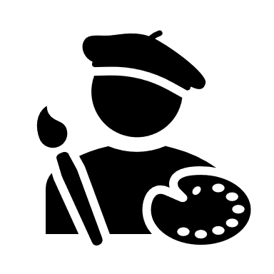
Al final de esta guía se espera que el estudiante desarrolle los
objetivos de aprendizaje relacionados con:
- Aplicar vocabulario temático de la unidad.
(OA1-0A8)

- Identify the following pictures and name them with the corresponding artists.

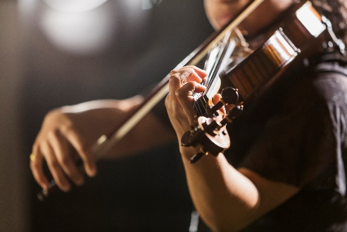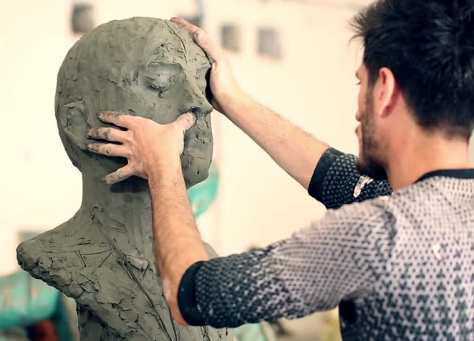
Musician Sculptor

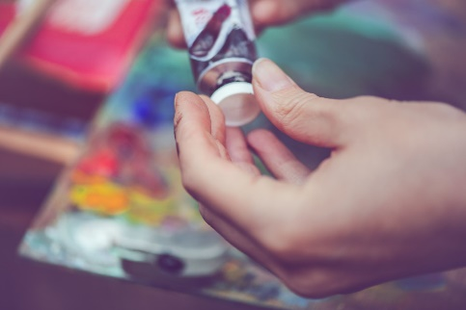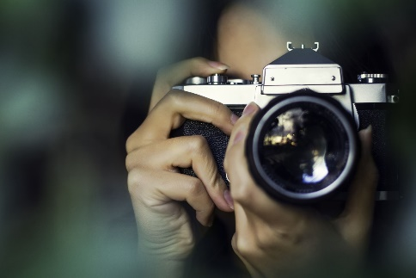
Artist Photographer

II. Complete the following sentences with the artists you can see on the box.

Dancer Artists Actor Writer Sculptor Musicians

- The sculptor supervised the placement of his newest sculpture in the garden.
- The writer of my favorite book said that the movie is coming on 2022!
- Madonna is one of the most amazing musicians of all the times, she has won a lot of different awards.
- There is an art gallery across the street, a lot of artists will show their work tomorrow.
- Did you watch the Superbowl? Shakira is an excellent dancer along with Jennifer Lopez.
- I didn’t like the play, the main actor was faking the sad scenes! It is the worst theater play of my life.

Nota:
Aquí están las respuestas correctas! Revisalas con calma y corrige.
Si al final de la guía lograste los 2 items correctos, excelente! Si solo lograste 1 ítem correcto, estas cerca del objetivo! Para resolver dudas puedes revisar de nuevo la clase correspondiente a esta guía en https://youtu.be/v_BuIpuTufk
Best Wishes! v

