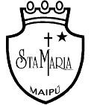
Colegio Santa María de Maipú
Departamento de Inglés

RETROALIMENTACIÓN WORKSHEET 7° Básico n° 14
Unit 3 “Sport and free-time activities” Semana 24 de agosto

OA: Escribir el verbo de manera correcta utilizando un diccionario y de acuerdo a lo enseñado en la cápsula
educativa.
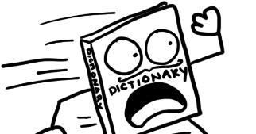
Use a dictionary, wordreference is a good online dictionary.

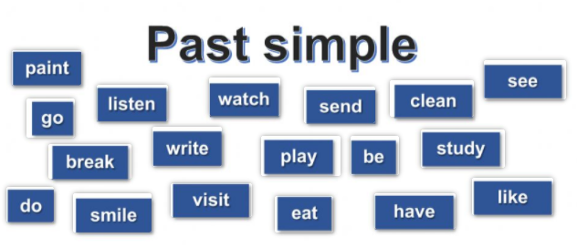
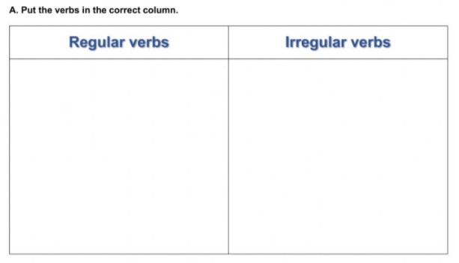
- WENT
- WROTE
- BROKE
- SENT
- SAW
- WAS/WERE
- HAD
- ATE
- DID

- PAINTED
- LISTENED
- WATCHED
- CLEANED
- PLAYED
- STUDIED
- SMILED
- VISITED
- LIKED

B.- Put the verbs into past simple tense.

1.- He __WROTE___ a letter two days ago. (write)
2.- They __PLAYED_____ GTA in the computer last night. (play)
3.- I _ATE____ a delicious breakfast in the morning. (eat)
4.- We __SAW___ our teacher in the park last week. (see)
5.- I __LISTENED___ an excellent audio-book. (listen)

