Colegio Santa María de Maipú
Departamento de Inglés

RETROALIMENTACIÓN
WORKSHEET 4° Básico n° 13
Unit 3 “What sport do you like?” Semana 24 de agosto
OA 13: Escribir (copiar o completar) palabras y oraciones simples de acuerdo a un modelo,
acerca de deportes, gustos y disgustos.

Do you like …..?
Read the sport and complete the sentence according your preferences
SPORT

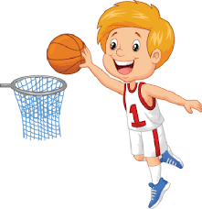 basketball | I like basketball. | I don´t like basketball.
 | I like football. | I don´t like football.
 | I like tennis. | I don´t like tennis.
 | I like boxing. | I don´t like boxing.
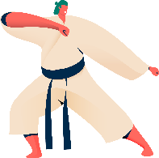 | I like karate. | I don´t like karate.
 | I like soccer. | I don´t like soccer.

Remember to write a sentence about your preferences use:

I + Like + Playing + sport
Love Practising
Don´t like
Hate

