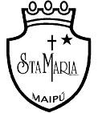
Colegio Santa María de Maipú
Departamento de Inglés

WORKSHEET 7° Básico n° 14
Unit 3 “Sport and free-time activities” Semana 24 de agosto

Watch the video and then complete the worksheet: https://youtu.be/4ooDrfoBUfo

OA: Escribir el verbo de manera correcta utilizando un diccionario y de acuerdo a lo enseñado en la cápsula
educativa.
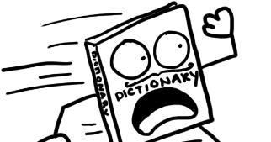
Use a dictionary, wordreference is a good online dictionary.

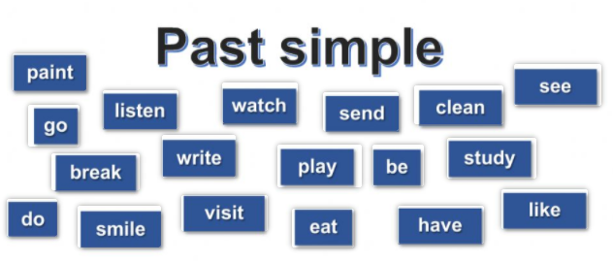
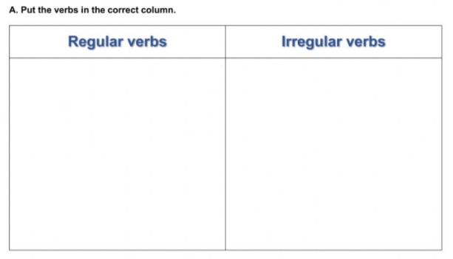

B.- Put the verbs into past simple tense.

1.- He _____ a letter two days ago. (write)
2.- They _______ GTA in the computer last night. (play)
3.- I _____ a delicious breakfast in the morning. (eat)
4.- We _____ our teacher in the park last week. (see)
5.- I _____ an excellent audio-book. (listen)

