Colegio Santa María de Maipú
Departamento de Inglés

Corrección Guía N°2 de autoaprendizaje de inglés 7° básico
Unit1 “ Feelings and opinions”
Name:______________________________________________________________ Date: ______________
OA: Dar informacion personal de manera escrita y expresar emociones.
My name is Lucy.
I’m 19.
My favourite pastimes are reading and shopping.
My favourite colour is pink.
I’m from England. I’m English.

I’m interested in art.
I’m a student.

Las respuestas varían de acuerdo a la información personal de cada alumno/a
Look at Lucy’s sentences. Now write sentences about yourself using the verb to be.
1. (name?)
My …is ……(nombre) ……………………………………………………………………………………………………..
2. (from?)
I ……am from …(país) ……………………………………………………………………………………….
3. (nationality?)
.......I am Chilean .....(u otra nacionalidad) ..........................................................................
4. (age?)
… I …am thirteen…( o el número de años) ……………………………………………………………………………………………………….
5. (job?)
…I am student……………………………………………………………………………………………………………….
6. (favourite colour or colours?)
……My favourite colors are blue, orange and red.………………………………………………....………………………………
7. (pastimes?)
……My favourite past times are (shopping and sleeping) …………………………………………………………………
8. (interested in … ?)
I am interested in (history )……………
Feelings
1.- Write next to each adjective if these are positive or negative emotion.

a. Friendly :___positive emotion___
b. Excited :____positive emotion________
c. Bored:___negative emotion__
d. Happy :__ positive emotion
e. Tired :__ negative emotion
f. Sad:_____ negative emotion
g. Worried:___ negative emotion
h.- Anxious:____ positive emotion ___________
i.- busy:___ negative emotion _____
j.- Well rested :__ positive emotion _

2.- Complete the sentences with these adjectives.
bored - tired - happy - sad
a. I feel __happy________when I get good grades at school.
b. Francisca feels ___bored______when her brother asks her to watch soap operas with him.
c. Daniel feels___tired______ after exercising too much after work.
d. I feel __sad_____ when I don’t spend time with my family for a long time.

3.- likes and dislikes
dislike - prefer - love - don’t like - hate - like - can’t stand – enjoy-
Usa las palabras del recuadro ubicandolas en el lugar que correponde. ¿Expresan likes or dislikes?

LIKES
__prefer_________________________________________love_______________________________________like__________________________________________enjoy_________________________________________________________________________________________________________________________________________________________________________
DISLIKES
___dislike____________________________________don’t______like___________________________________hate___________________________ _____
can’t stand________________________________________________________________________________________________________________
4.- Writing : Utiliza al menos 4 expresiones para expresar likes or dislikes y crea una frase.
a.___I can’t stand pop music.______________________________________________________________
b.___I love music_________________________________________________________________________
c.___I hate rice _________________________________________________________________
d.___I like playing video games_____________________________________________________________________
e.___I enjoy your company___________________________________________________________________

5.- Complete the phone conversation with the correct words.
tired - worried - well rested - anxious - busy

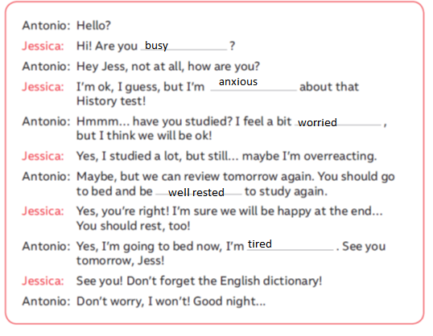
Nota: Cada respuesta correcta suma 1 punto, el puntaje total de la guía es de 38 puntos.
Menos de 26 puntos: Debes rehacer la guía y volver a reforzar los contenidos que se te hicieron más difíciles, busca apoyo en tu texto de estudio (student book and activity book) o en internet, esto será de gran ayuda para progresar.
27 puntos o más: FELICITACIONES! Lograste el objetivo de la guía puedes pasar sin problemas a la guía de autoaprendizaje n°3.

