“MY CLOTHES”
Unit 1 :

Name_____________________________________________Grade________
*Esta actividad debe ser guiada por el padre o apoderando del estudiante.

I.- Read the word and circle the correct image. (leer la palabra y encerrar en un circulo la imagen correcta)
- SHORT
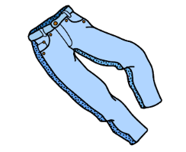
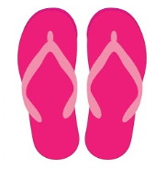
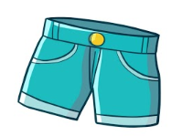

B) T- SHIRT
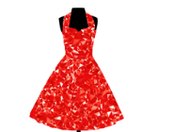
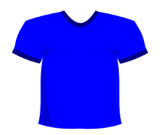

II.- Read and draw one character with the correct clothing and color . (leer y dibujar 1 personaje con su correcta ropa y color)
Betty: hi, how are you?
Jhon: I´m good and you?
Betty: I´m very happy because I´m wearing my purple t – shirt and pink shorts. These are my favorite outfit.
Jhon: That´s nice. I´m wearing yellow pants and a red jacket. I like it too.
Betty: I see you soon. Bye
Jhon: Bye. Stay at home.

