GUIA DE AUTOAPRENDIZAJE N°10 INGLÉS
8° BÁSICO
UNIT 2: COUNTRIES, CULTURES AND COSTUMES

Class: https://youtu.be/PsNhmC8t5Ls

Al final de esta guía se espera que el estudiante desarrolle los objetivos de aprendizaje relacionados con:

- Aplicar vocabulario temático nuevo de la unidad.
- Reconocer imágenes y unirlas con conceptos.
(OA8-0A14)

In this worksheet you will apply the vocabulary spot seen on the class.

Advices to travel:
Visit a place: visitar un lugar
Marvel wonders of nature: contemplar la naturaleza
Try local food: probar comida típica
Enjoy the culture: disfrutar la cultura

Countries and Nationalities:
You can have countries, for example, United States, and you can have the nationality of the people who live there. Their nationality is “American”, they can say “I am American”.
Some Examples:
I’m from Chile. I am Chilean.
I’m from Japan. I am Japanese.
I’m from Italy. I am Italian.

- Vocabulary Spot: Name each picture related to the advices of travelling.

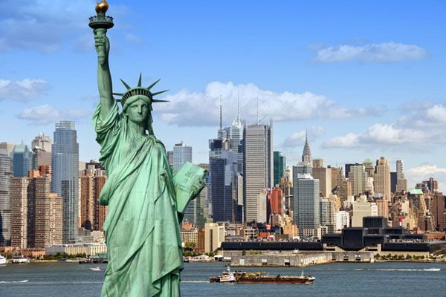
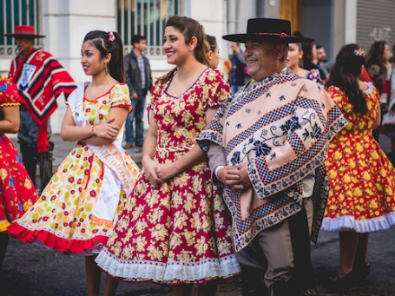

________________________ ________________________

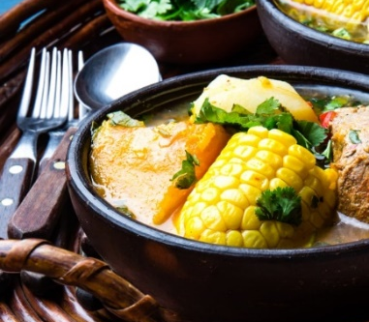

________________________ ________________________

- Vocabulary Spot: Find the different nationalities on the word search, and write their country.
Example: Canada Canadian

Chinese - Irish – American – Polish –
Brazilian - Spanish - New Zealander- Mexican

Pay attention to the lesson, read carefully and use your
dictionary or internet (wordreference is a good online dictionary)
Remember to write down your answers to ask in our weekly online lessons!
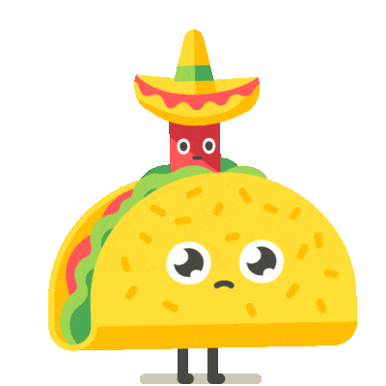
You can do it!

