GUIA DE AUTOAPRENDIZAJE Nº11 INGLÉS
IIIº MEDIO

Nombre_______________________________________ Curso:_______ Fecha: _______
En esta guía el estudiante estará practicando las habilidades que el idioma inglés requiere para mantener una continuidad en su proceso de aprendizaje.

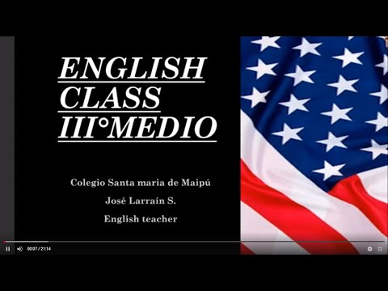
I.- WATCH THE FOLLOWING VIDEO AND USE YOUR NOTEBOOK WHEN YOU ARE TOLD TO. (CLICK ON THE IMAGE BELOW AND THE VIDEO WILL PLAY AUTOMATICALLY)

- DON’T FORGET TO COMPLETE THE ACTIVITIES PROVIDED ON THE VIDEO ABOVE, USE YOUR NOTEBOOK TO KEEP RECORDS OF THEM.
II.- COMPLETE THE FOLLOWING CHART WITH THE MISSING INFORMATIOMN FROM THE VIDEO ABOVE.

1. The dog had fleas. He always scratched _____________.

2. I shave _____________ every morning before I go to work.

3. Tom usually cuts his hair _____________

4. Carol is already able to dress _____________

5. My computer system is damaged. It turns _____________ off.

6. I'm not going to do that for you. You can do it _____________.

7. Mike's son is old enough to cook for _____________ now.

8. Susan and I walked to the store _____________.

9. They stood in front of the mirror and looked at _____________.

10. When we go to the restaurant, I'll pay for my food and you can pay for yours _______.

11. He drives _____________ to work every day.

12. Mary doesn't like to drive _____________ to work. So, she usually takes the underground.

13. The book was on the floor. It fell off the shelf _____________.

14. I asked him for a glass of water, and he told me to get it_____________.
.
15. Rick and Maria are able to look after _____________.
.

*note: you can find out the right answers in the link provided in the instructions.

CONTACT INFO: ING.TERCEROMEDIO.SMM@GMAIL.COM

For further information feel free to look up on the internet.

