GUIA DE AUTOAPRENDIZAJE Nº10 INGLÉS
IVº MEDIO

Nombre_______________________________________ Curso:_______ Fecha: _______
En esta guía el estudiante estará practicando las habilidades que el idioma inglés requiere para mantener una continuidad en su proceso de aprendizaje.

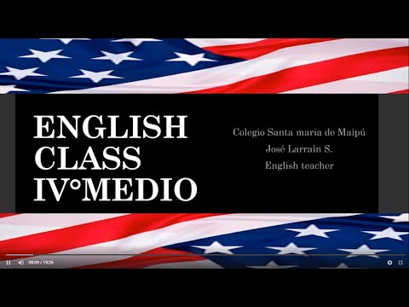
I.- WATCH THE FOLLOWING VIDEO AND USE YOUR NOTEBOOK WHEN YOU ARE TOLD TO.
(CLICK ON THE IMAGE BELOW AND THE VIDEO WILL PLAY AUTOMATICALLY)

- DON’T FORGET TO COMPLETE THE ACTIVITIES PROVIDED ON THE VIDEO ABOVE, USE YOUR NOTEBOOK TO KEEP RECORDS OF THEM.

II.-REWRITE THESE SENTENCESFROM ACTIVE TO PASSIVE VOICE.

- 1.- My brother walks the dog.
- ________________________________.

- 2.- He opened the window.
- ________________________________.

- 3.- Someone has stolen my treasure.
- ________________________________.

- 4.- They will sell the house. ________________________________.

- 5.- Sam is washing the car.
- ________________________________.

III.-REWRITE THESE SENTENCESFROM PASSIVE TO ACTIVE VOICE.

1.- A novel is being read by Mary
________________________________.
2. A car has been bought by him.
________________________________.
3.- The jackpot will be won by her.
________________________________.
4.- The fish is eaten by the cat.
________________________________.
5.- A letter was written to him by her.
________________________________.
IV.- COMPLEMENTARY ACTIVITIES: LISTENING COMPREHENSION. Listen to the following audio and answer the questions below. https://www.esl-lab.com/intermediate/family-history/

1.- When was Ana Maria Cavazos born?
a.- June 8, 1908
b.- June 7, 1908
c.- June 9, 1908

2.- Ana Maria was born in ____.
a.- New Mexico
b.- Mexico
c.- Texas

3.- How many brothers and sisters did she have?
a.- 12
b.- 11
c.- 13

4.- Ana's father was originally from ____.
a.- Mexico
b.- Texas
c.- California

5.- Ana's parents got married in ____.
a.- 1882
b.- 1878
c.- 1880

*note: you can find out the right answers in the link provided in the instructions.

CONTACT INFO: ING.CUARTOMEDIO.SMM@GMAIL.COM

