GUIA DE AUTOAPRENDIZAJE Nº11 INGLÉS
IVº MEDIO

Nombre_______________________________________ Curso:_______ Fecha: _______
En esta guía el estudiante estará practicando las habilidades que el idioma inglés requiere para mantener una continuidad en su proceso de aprendizaje.

I.- WATCH THE FOLLOWING VIDEO AND USE YOUR NOTEBOOK WHEN YOU ARE TOLD TO.
(CLICK ON THE IMAGE BELOW AND THE VIDEO WILL PLAY AUTOMATICALLY)
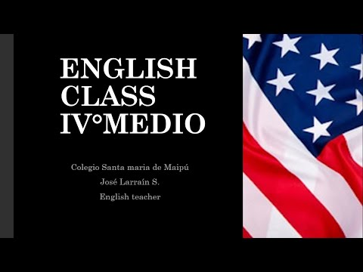
- DON’T FORGET TO COMPLETE THE ACTIVITIES PROVIDED ON THE VIDEO ABOVE, USE YOUR NOTEBOOK TO KEEP RECORDS OF THEM.

II.-COMPLETE THESE SENTENCES WITH THE PROPER QUESTION TAG.

1. She’s from a small town in China, ________________ ?
2. They aren’t on their way already, ________________ ?
3. We’re late again, ________________ ?
4. I’m not the person with the tickets, ________________ ?
5. Julie isn’t an accountant, ________________ ?
6. The weather is really bad today, ________________ ?
7. He’s very handsome, ________________ ?
8. They aren’t in Mumbai at the moment, ______________ ?
9. You aren’t from Brazil, ________________ ?
10. John’s a very good student, ________________ ?
11. I like chocolate very much, ________________ ?
12. She doesn’t work in a hotel, ________________ ?
13. They need some new clothes, ________________ ?
14. We live in a tiny flat, ________________ ?
15. She studies very hard every night, ________________ ?
16. David and Julie don’t take Chinese classes, _________ ?
17. I often come home late, ________________ ?
18. You don’t like spicy food, ________________ ?
19. She doesn’t cook very often, ________________ ?
20. We don’t watch much TV, ________________ ?

*note: you can find out the right answers in the link provided in the instructions.

CONTACT INFO: ING.CUARTOMEDIO.SMM@GMAIL.COM

