ANSWER KEY
GUÍA DE AUTOAPRENDIZAJE Nº10 INGLÉS
IIº MEDIO

Nombre_______________________________________ Curso:______ Fecha: _______
En esta guía el estudiante estará practicando las habilidades que el idioma inglés requiere para mantener una continuidad en su proceso de aprendizaje.

I.- WATCH THE FOLLOWING VIDEO AND USE YOUR NOTEBOOK WHEN YOU ARE TOLD TO.
(CLICK ON THE IMAGE BELOW AND THE VIDEO WILL PLAY AUTOMATICALLY)
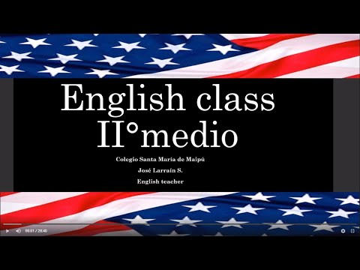

II.-COMPLETE THE SENTENCES USING A – AN – ANY – SOME.

1.- Are there ___ANY_____ eggs in the fridge?

2.- There’s ___A___ policeman at the door.

3.- Is there ____ANY____ news about the plane crash?

4.- There was ____AN______ accident on the bridge last night.

5.- There are ___SOME_____ good films on at the moment.

6.- Have you got ___ANY____ antiseptic cream?

7.- ___SOME____flowers arrived for you this morning.

III.-COMPLETE THE SENTENCES USING MUCH – MANY – A LOT OF.

1.- Do you have any cereal? Sure, there’s ______A LOT____ in the kitchen."

2.- How ____MUCH___ is this? It's ten dollars.

3.- How _____MANY____ do you want? Six, please.

5.- He's very busy; he has ______A LOT OF ____ work.

6.- David has ____A LOT OF____ rice, but Tyler doesn't have .

7.- London has _____A LOT OF_____ beautiful buildings.

III.- COMPLEMENTARY ACTIVITIES: LISTENING COMPREHENSION, Listen to the following audio and answer the questions below. https://www.esl-lab.com/easy/private-tutor/
1.- What is the man's name?
A.- His name is Mike.
B.- His friends call him Nate.
C.- He goes by Nick.

2.- Where is the man from?
A.- He's from Brownston.
B.- He's originally from Brownsville.
C.- His hometown is Brownsburg.

3.- How old is the man?
A.- He's in his mid-twenties.
B.- He's in his early twenties.
C.- He's in his late twenties.

4.- Where did the man meet Sarah?
A.- They were introduced at a party.
B.- He saw her in a language class.
C.- He met her on a bus.

5.- Sarah's older sister is worried that Nick _____.
A.- is a terrible language teacher
B- charges too much money for lessons
C.- is going to be a negative influence on her

*note: you can find out the right answers in the link provided in the instructions.

CONTACT INFO: ingles.ii.smm@gmail.com

