GUIA DE AUTOAPRENDIZAJE N°11 INGLÉS
8° BÁSICO
UNIT 2: COUNTRIES, CULTURES AND COSTUMES

Class: https://youtu.be/PsNhmC8t5Ls

Al final de esta guía se espera que el estudiante desarrolle los objetivos de aprendizaje relacionados con:

- Aplicar vocabulario temático nuevo de la unidad.
- Reconocer usos de make y do.
(OA1-0A14)

In this worksheet you will apply the vocabulary spot seen on the class.

Countries and Nationalities:
You can have countries, for example, United States, and you can have the nationality of the people who live there. Their nationality is “American”, they can say “I am American”.
Some Examples:
I’m from Egypt. I am Egyptian.
I’m from Poland. I am Polish.

- Vocabulary Spot: Write the nationalities of the following countries.

- India: Indian
- Thailand:
- Germany:
- Egypt:
- Argentina:
- Spain:
- Peru:
- China:
- Australia:
- Poland:

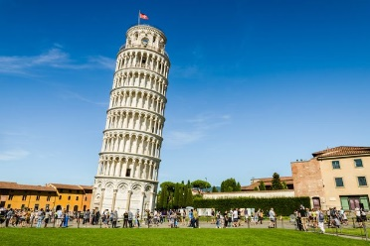
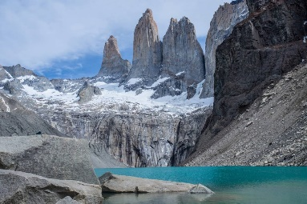
- Vocabulary Spot: Where is it? Write down the name of the country in which these places are.
______________________ _______________________ _____________________

Remember:
- We use the verb “do”for actions, obligations, and repetitive tasks.
- We use the verb “make” for creating or producing something, and for actions you choose to do.

- Grammar Spot: Write in your notebook the correct verbs (make or do) for the corresponding verbs. (Page 42 student’s book)
Example: Make the bed.

friends - a favor - yoga - the bed - the shopping -
the laundry - a mess - noise

Make:
Do:

Pay attention to the lesson, read carefully and use your
dictionary or internet (wordreference is a good online dictionary)
Remember to write down your answers to ask in our weekly online lessons!
You can do it!

