GUIA Nº10 INGLÉS
6° GRADE

NAME: ______________________________________ DATE:____________________
Objetivo de Aprendizaje: Expresión oral OA12. Expresión escrita OA14.
- El estudiante dará direcciones de forma oral y escrita.
Instrucciones:
- Completa esta guía solo si no tienes tus libros de inglés.
- Mira el video con los contenidos de la semana en YouTube. El enlace al video está en tu agenda semanal.
- Completa las actividades a medida que el video te lo indique.
- Completa el quiz al final de la guía. Si tienes internet puedes realizarlo en Google Forms. El enlace al quiz está en tu agenda semanal.

GIVING DIRECTIONS: DANDO DIRECCIONES

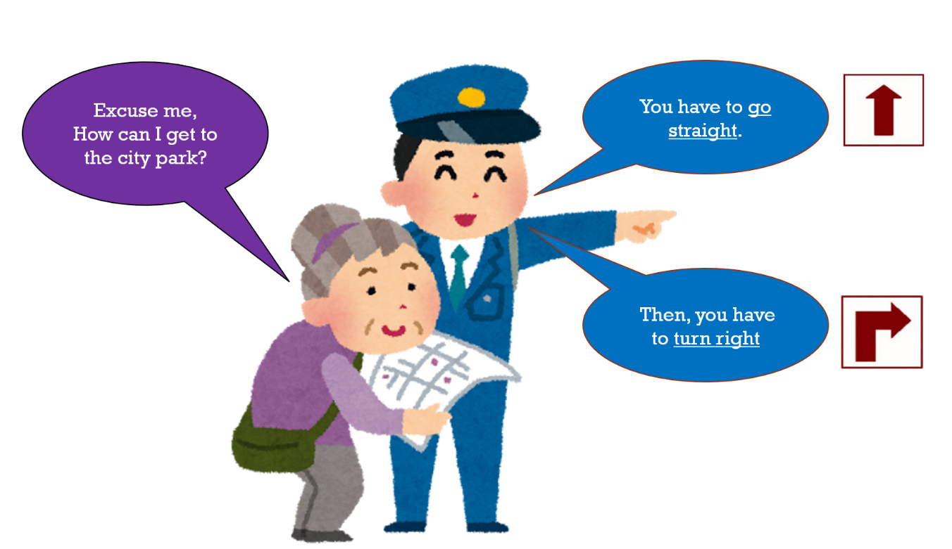

ABUELITA: Discúlpeme, ¿Cómo puedo llegar al parque de la ciudad?
POLICIA: Usted tiene que ir derecho. Después, usted tiene que doblar a la derecha.

- Mira al mapa y da direcciones. Tú estás en la cruz roja.
ACTIVITY:

3) Look at the map and write directions. You are in the red cross.
- Cubre las palabras del ejercicio 1. Luego, escucha y apunta con tu mano a la dirección que escuchas. (Los audios están en el video n°10).
Letra | Español | Pronunciación
a. | Ir derecho | Gou streit
b. | Doblar a la izquierda | Tern left
c. | Doblar a la derecha | Tern rait
d. | Cross Cruzar la calle | Cros de strit

- Mira escucha y repite.
- How can you get to the hospital?
__________________________________________________________________________________________________________________________________________________________________________________________________________________
- How can you get to the supermarket?
__________________________________________________________________________________________________________________________________________________________________________________________________________________
- How can you get to the post office?
__________________________________________________________________________________________________________________________________________________________________________________________________________________
Quiz N°6

1.- What is this picture?
¿Qué es esta imagen?
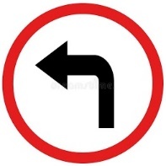  - Go straight  - Turn left  - Turn right  - Cross the street | 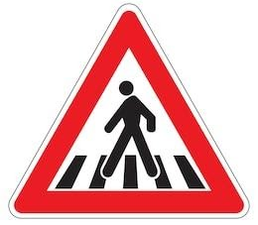  - Go straight  - Turn left  - Turn right  - Cross the street
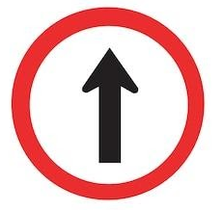  - Go straight  - Turn left  - Turn right  - Cross the street | 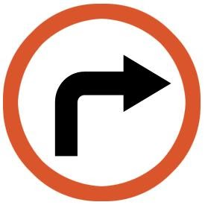  - Go straight  - Turn left  - Turn right  - Cross the street
2.- Look at the map and choose the correct directions. You are in the red cross.
Mira el mapa y escoge la dirección correcta. Tú estás en la cruz roja.
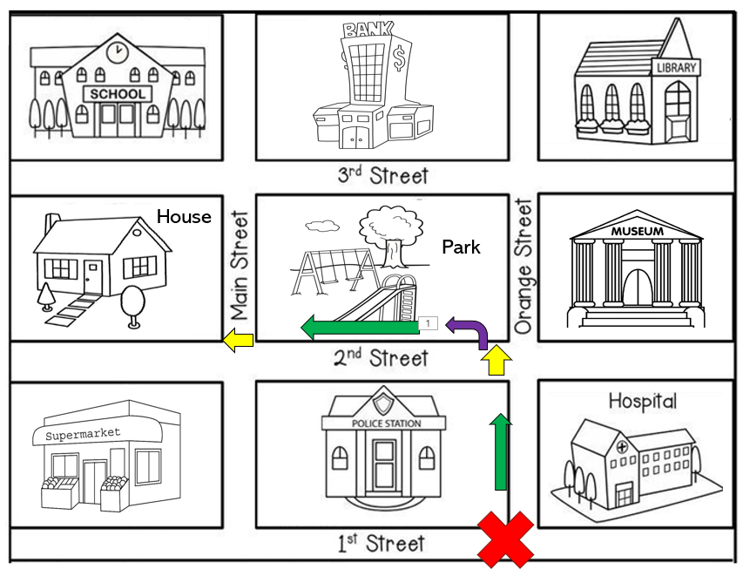
- Go straight. Cross 2nd Street. Turn left. Go straight. Cross Main Street.
- Cross 2nd Street. Turn left. Go straight. Cross Main Street. Go straight.
- Go straight. Cross 2nd Street. Turn right. Go straight. Cross Main Street.

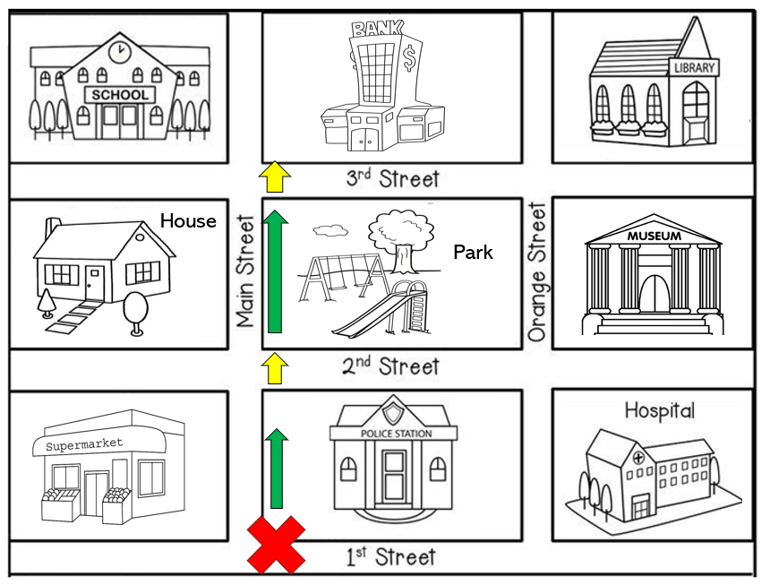
- Go straight. Cross 1st Street. Go straight. Cross 2nd Street.
- Go straight. Cross 2nd Street. Go straight. Cross 3rd Street.
- Cross 2nd Street. Go straight. Cross 3rd Street. Go straight.

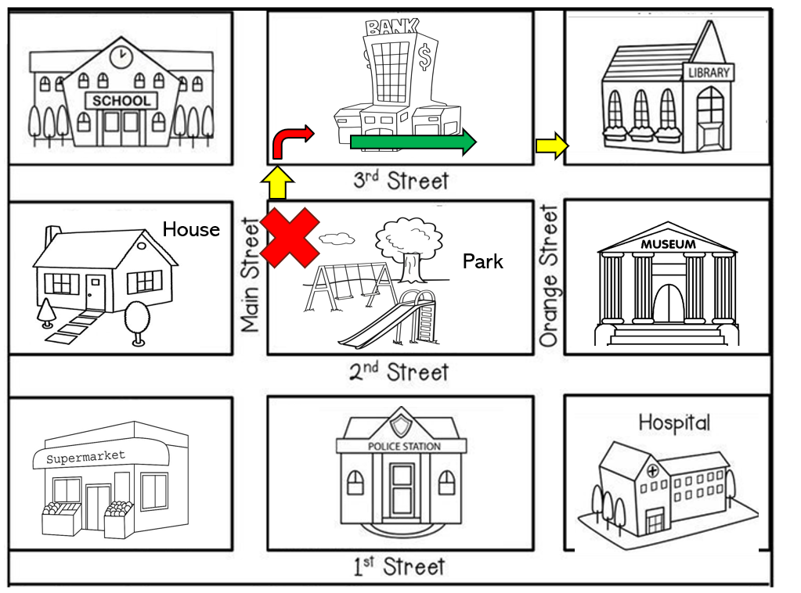
- Cross 2nd Street. Turn right. Go straight. Cross Orange Street
- Cross 3rd Street. Turn right. Go straight. Cross Orange Street
- Cross 3rd Street. Turn left. Go straight. Cross Orange Street

