GUIA DE AUTOAPRENDIZAJE Nº10 INGLÉS
I° MEDIO
UNIT 2: KEEP ON LEARNING

Class: https://youtu.be/3rzmR2uOFe4

Al final de esta guía se espera que el estudiante desarrolle los objetivos de aprendizaje relacionados con:

- Aplicar vocabulario temático de la unidad.
- Reforzar el uso de comparativos y superlativos.
(OA8-0A9)

Tips for studying
- There are many types of studying but here we are going to see 4 tips for studying.

1. Note-taking: taking notes or making a summary about a subject.
2. Word-map: you can create it to organize ideas and words.
3. Highlight: you emphasize the most important ideas of something.
4. Study plan: you can create it to organize a course and your time for doing something.

- Vocabulary Spot: Guess the name of each tip for studying present in the pictures.
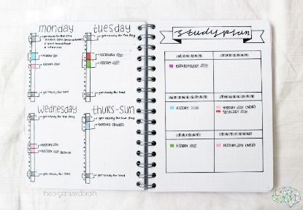

________________________

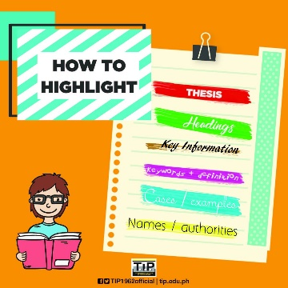

________________________

_______________________
________________________

Comparative and Superlative adjectives
Comparatives
We use comparative adjectives to show change or make comparisons:

This car is certainly better.
I'm feeling happier now.

We use than when we want to compare one thing with another: She is two years older than me.

Superlatives
We use the with superlative adjectives:

It was the happiest day of my life.
That’s the best film I have seen this year.

Examples: old/ older / oldest
long/ longer/ longest

- Write the comparatives and Superlatives of each adjective
Example: Smart Smarter (comparative)
Smartest (superlative)

Adjectives | Comparatives | Superlatives
smart  ugly beautiful fast  slow  pretty  tall  short  bad  good  old  young | Smarter | Smartest

- Create 4 sentences using 2 comparatives and 2 superlatives from the last item.
Example: Smart I am the smarter than you.
- Emily is the smartest in the class.

- ______________________________
- ______________________________
- ______________________________
- ______________________________

Pay attention to the lesson, read carefully and use your
dictionary or internet (wordreference is a good
online dictionary)
Remember to write down your answers
to ask in our weekly online lessons!
You can do it!

