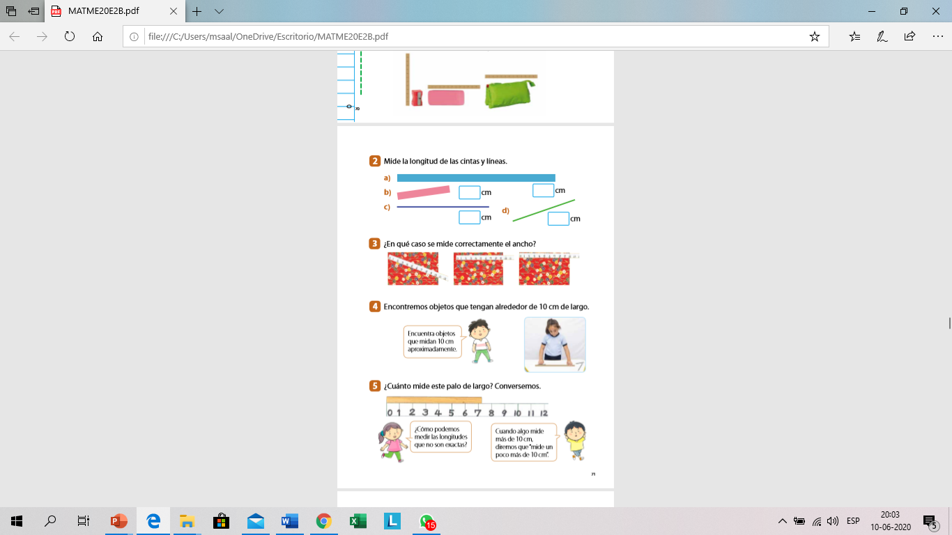 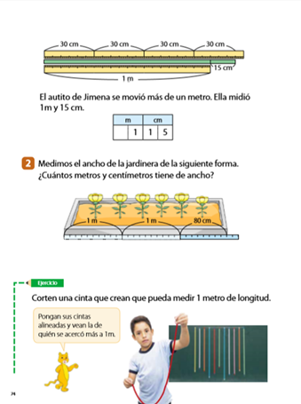 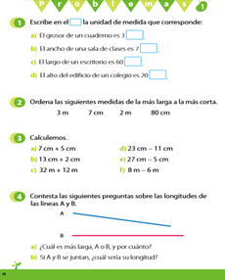

**9cm +8cm = 17cm**

**R : es mas largo b por 1cm**

**4**

**12**

**5**

**7**

|  |
| --- |
| **34 cm** |
| **32cm** |
| **2m** |

|  |
| --- |
| **12 cm** |
| **15 cm** |
| **44 cm** |

**7cm**

**8cm**

**2m**

**3m**

|  |  |  |  |
| --- | --- | --- | --- |
|  |  |  |  |

m

cm

m

cm

**TRABAJA EN FAMILIA**

0

8

2



**7 CMS**