GUIA DE AUTOAPRENDIZAJE N°12 INGLÉS
8° BÁSICO
UNIT 2: COUNTRIES, CULTURES AND COSTUMES

Class: https://youtu.be/lv3X9262WCg

Al final de esta guía se espera que el estudiante desarrolle los objetivos de aprendizaje relacionados con:

- Aplicar vocabulario temático nuevo de la unidad.
- Reconocer usos de make y do.
(OA1-0A9)

In this worksheet you will apply the vocabulary spot seen on the class.

Cultural Places and Traditions to visit
You visit different places as cities, natural places, countries. Also, you can visit and participate in different cultural traditions from different countries. We will study 4:
Carnival Temple
Cultural Exhibition Parade

- Vocabulary Spot: What is it? Write down which cultural place is the picture related with. (Carnival, temple, parade, cultural exhibition)

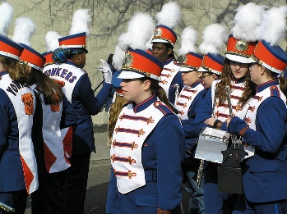
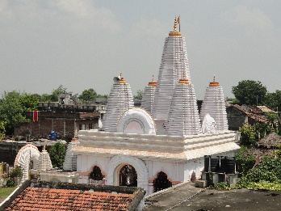
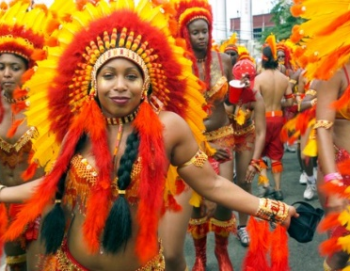
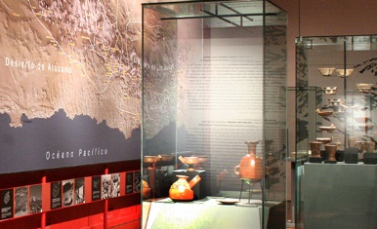

______________ _____________ ______________ ______________

Remember:
- We use the verb “do”for actions, obligations, and repetitive tasks.
- We use the verb “make” for creating or producing something, and for actions you choose to do.

- Grammar Spot: Write in your notebook the correct verbs (make or do) for the corresponding verbs.
Example: I make friends at the school / I do the shopping every Friday.

- Ops! I __________ a mistake with your friend.
- Hey! Please can you __________me a favour?
- My mom __________ the housework everyday.
- I __________ my homework yesterday. (not)
- My little sister __________ a mess in my room.
- Did you __________ this chocolate cake? It’s delicious!
- Please, I need to __________ breakfast before 8 am!

Pay attention to the lesson, read carefully and use your
dictionary or internet (wordreference is a good online dictionary)
Remember to write down your answers to ask in our weekly online lessons!
You can do it!

