GUIA DE AUTOAPRENDIZAJE N°12 INGLÉS
8° BÁSICO
UNIT 2: COUNTRIES, CULTURES AND COSTUMES
ANSWERS

Class: https://youtu.be/lv3X9262WCg

Al final de esta guía se espera que el estudiante desarrolle los objetivos de aprendizaje relacionados con:

- Aplicar vocabulario temático nuevo de la unidad.
- Reconocer usos de make y do.
(OA1-0A9)

In this worksheet you will apply the vocabulary spot seen on the class.

Cultural Places and Traditions to visit
You visit different places as cities, natural places, countries. Also, you can visit and participate in different cultural traditions from different countries. We will study 4:
Carnival Temple
Cultural Exhibition Parade

- Vocabulary Spot: What is it? Write down which cultural place is the picture related with. (Carnival, temple, parade, cultural exhibition)

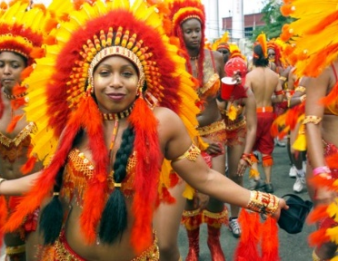
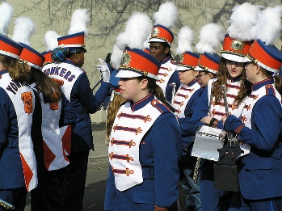
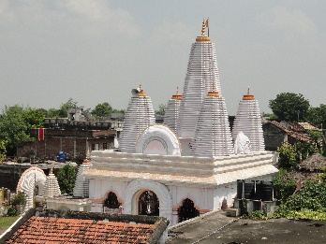
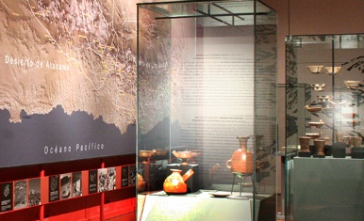

PARADE CULTURAL EXHIBITION TEMPLE CARNIVAL

Remember:
- We use the verb “do”for actions, obligations, and repetitive tasks.
- We use the verb “make” for creating or producing something, and for actions you choose to do.

- Grammar Spot: Write in your notebook the correct verbs (make or do) for the corresponding verbs.
Example: I make friends at the school / I do the shopping every Friday.

- Ops! I MAKE a mistake with your friend.
- Hey! Please can you DO me a favour?
- My mom DOES the housework everyday.
- I DID NOT DO my homework yesterday. (not)
- My little sister MADE a mess in my room.
- Did you MAKE this chocolate cake? It’s delicious!
- Please, I need to MAKE breakfast before 8 am!

Nota:
Espero las respuestas correctas te hayan servido!
Es importante este material, ya que es el vocabulario de la unidad “countries, cultures and costumes”.
Si al final de la guía lograste 2 items correctos, felicitaciones! Si solo lograste 1 ítem correcto, tu puedes!
Pone atención en los errores para la próxima y revisa de nuevo el link de la clase en: https://youtu.be/lv3X9262WCg
You can do it!
You can do it!

