GUIA DE AUTOAPRENDIZAJE N°11 INGLÉS
8° BÁSICO
UNIT 2: COUNTRIES, CULTURES AND COSTUMES

Class: https://youtu.be/PsNhmC8t5Ls

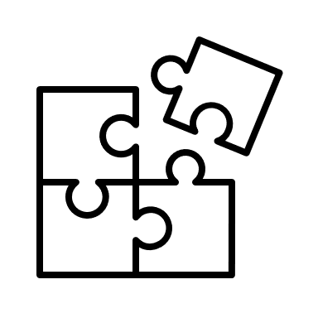
Al final de esta guía se espera que el estudiante desarrolle los objetivos de aprendizaje relacionados con:

- Aplicar vocabulario temático nuevo de la unidad.
- Reconocer usos de make y do.
(OA1-0A14)

In this worksheet you will apply the vocabulary spot and grammar spot seen on the class.

Countries and Nationalities:
You can have countries, for example, United States, and you can have the nationality of the people who live there. Their nationality is “American”, they can say “I am American”.
Some Examples:
I’m from Egypt. I am Egyptian.
I’m from Poland. I am Polish.

- Vocabulary Spot: Write the nationalities of the following countries.

- India: Indian
- Thailand: Thai
- Germany: German
- Egypt: Egyptian
- Argentina: Argentinian
- Spain: Spanish
- Peru: Peruvian
- China: Chinese
- Australia: Australian
- Poland: Polish

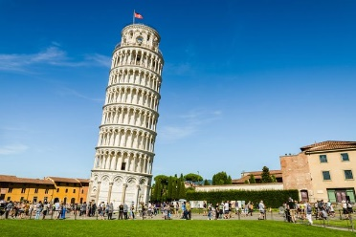
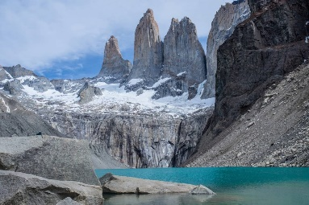
- Vocabulary Spot: Where is it? Write down the name of the country in which these places are.
Big Ben: England Pisa Tower: Italy Torres del Paine: Chile

Remember:
- We use the verb “do”for actions, obligations, and repetitive tasks.
- We use the verb “make” for creating or producing something, and for actions you choose to do.

- Grammar Spot: Write in your notebook the correct verbs (make or do) for the corresponding verbs. (Page 42 student’s book)
Example: Make the bed.

friends - a favor - yoga - the bed - the shopping -
the laundry - a mess - noise

MAKE: friends - the bed - a mess
- noise.
DO: a favor - yoga - the shopping -
the laundry.

Nota:
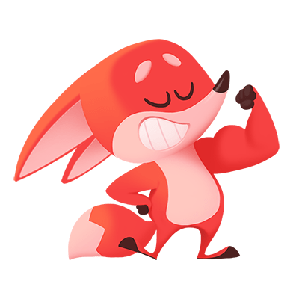
Espero las respuestas correctas te hayan servido!
Es importante este material, ya que es el vocabulario de la unidad “countries, cultures and costumes”.
Si al final de la guía lograste 2 items correctos, felicitaciones! Si solo lograste 1 ítem correcto, tu puedes!
Estas a punto de alcanzar el objetivo! Pone atención en los errores para la próxima y revisa de nuevo el link de la clase en: https://youtu.be/PsNhmC8t5Ls
You can do it!
You can do it!

