ANSWER SHEET
GUIA DE AUTOAPRENDIZAJE Nº12 INGLÉS
IVº MEDIO

Nombre_______________________________________ Curso:_______ Fecha: _______
En esta guía el estudiante estará practicando las habilidades que el idioma inglés requiere para mantener una continuidad en su proceso de aprendizaje.

I.- WATCH THE FOLLOWING VIDEO AND USE YOUR NOTEBOOK WHEN YOU ARE TOLD TO.
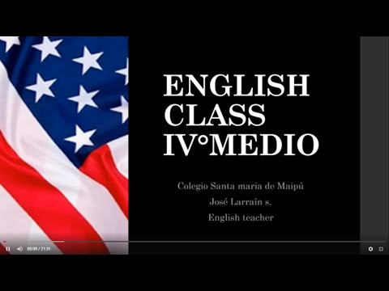
(CLICK ON THE IMAGE BELOW AND THE VIDEO WILL PLAY AUTOMATICALLY)
- DON’T FORGET TO COMPLETE THE ACTIVITIES PROVIDED ON THE VIDEO ABOVE, USE YOUR NOTEBOOK TO KEEP RECORDS OF THEM.

II.-COMPLETE THESE SENTENCES WITH THE PROPER QUESTION TAG.
1.- She's Italian, ____ISN’T SHE_______?
2.- They live in London, _____DON’T THEY______?
3.- We're working tomorrow, _____AREN’T WE______?
4.- It was cold yesterday, _____WASN’T IT______?
5.- He went to the party last night, _____DIDN’T HE______?
6.- We were waiting at the station, ____WEREN’T WE_______?
7.- She doesn't have any children, __DOES SHE____?
8.- The bus isn't coming, ____IS IT_________?
9.- She wasn't at home yesterday, ____WAS SHE___?
10.- They didn't go out last Sunday, ___DID THEY_?
11.- You weren't sleeping, ___WERE YOU_____?

*note: you can find out the right answers in the link provided in the instructions.

CONTACT INFO: ING.CUARTOMEDIO.SMM@GMAIL.COM

