ANSWER SHEET
GUIA DE AUTOAPRENDIZAJE Nº11 INGLÉS
IIIº MEDIO

Nombre_______________________________________ Curso:_______ Fecha: _______
En esta guía el estudiante estará practicando las habilidades que el idioma inglés requiere para mantener una continuidad en su proceso de aprendizaje.

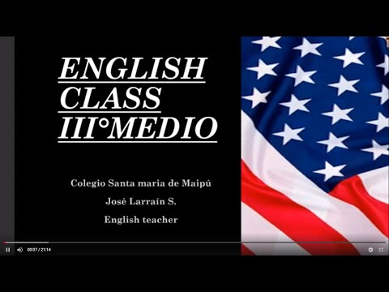
I.- WATCH THE FOLLOWING VIDEO AND USE YOUR NOTEBOOK WHEN YOU ARE TOLD TO. (CLICK ON THE IMAGE BELOW AND THE VIDEO WILL PLAY AUTOMATICALLY)

- DON’T FORGET TO COMPLETE THE ACTIVITIES PROVIDED ON THE VIDEO ABOVE, USE YOUR NOTEBOOK TO KEEP RECORDS OF THEM.
II.- COMPLETE THE FOLLOWING CHART WITH THE MISSING INFORMATIOMN FROM THE VIDEO ABOVE.

1. The dog had fleas. He always scratched ______ITSELF_______.

2. I shave ______MYSELF_______ every morning before I go to work.

3. Tom usually cuts his hair _____HIMSELF________

4. Carol is already able to dress _____HERSELF________

5. My computer system is damaged. It turns ______ITSELF_______ off.

6. I'm not going to do that for you. You can do it _____YOURSELF________.

7. Mike's son is old enough to cook for ______HIMSELF_______ now.

8. Susan and I walked to the store _____OURSELVES________.

9. They stood in front of the mirror and looked at _____THEMSELVES________.

10. When we go to the restaurant, I'll pay for my food and you can pay for yours __YOURSELF_____.

11. He drives ______HIMSELF_______ to work every day.

12. Mary doesn't like to drive ______HERSELF_______ to work. So, she usually takes the underground.

13. The book was on the floor. It fell off the shelf ______ITSELF_______.

14. I asked him for a glass of water, and he told me to get it_______MYSELF______.
.
15. Rick and Maria are able to look after _____THEMSELVES________.
.

*note: you can find out the right answers in the link provided in the instructions.

CONTACT INFO: ING.TERCEROMEDIO.SMM@GMAIL.COM

For further information feel free to look up on the internet.

