GUIA DE AUTOAPRENDIZAJE Nº12 INGLÉS
IIIº MEDIO

Nombre_______________________________________ Curso:_______ Fecha: _______
En esta guía el estudiante estará practicando las habilidades que el idioma inglés requiere para mantener una continuidad en su proceso de aprendizaje.

I.- WATCH THE FOLLOWING VIDEO AND USE YOUR NOTEBOOK WHEN YOU ARE TOLD TO. (CLICK ON THE IMAGE BELOW AND THE VIDEO WILL PLAY AUTOMATICALLY)
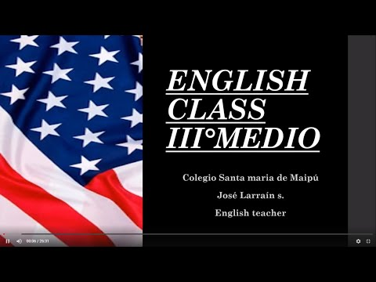

- DON’T FORGET TO COMPLETE THE ACTIVITIES PROVIDED ON THE VIDEO ABOVE, USE YOUR NOTEBOOK TO KEEP RECORDS OF THEM.
II.- COMPLETE THE FOLLOWING CHART WITH THE MISSING INFORMATIOMN FROM THE VIDEO ABOVE.

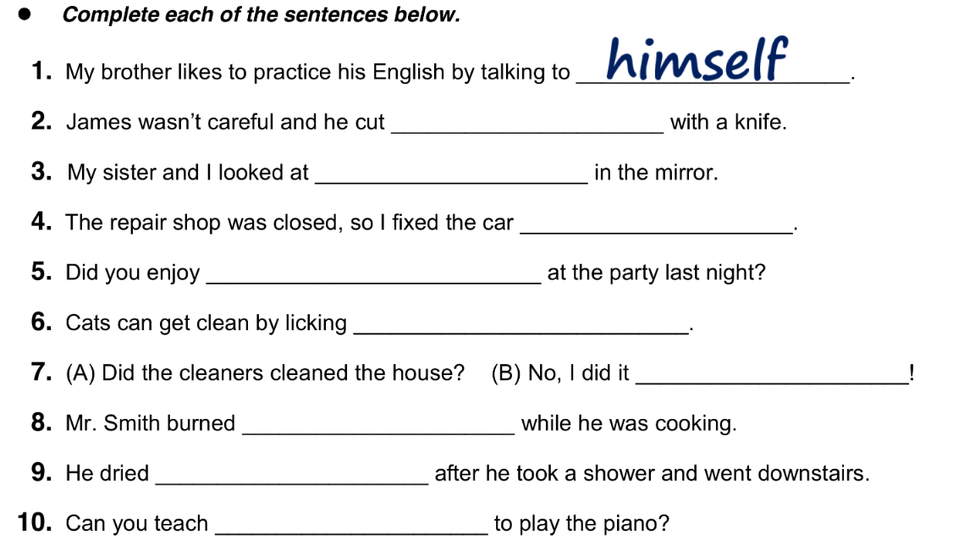.

*note: you can find out the right answers in the link provided in the instructions.

CONTACT INFO: ING.TERCEROMEDIO.SMM@GMAIL.COM

