GUÍA DE AUTOAPRENDIZAJE Nº12 INGLÉS
IIº MEDIO

Nombre_______________________________________ Curso:______ Fecha: _______
En esta guía el estudiante estará practicando las habilidades que el idioma inglés requiere para mantener una continuidad en su proceso de aprendizaje.

I.- WATCH THE FOLLOWING VIDEO AND USE YOUR NOTEBOOK WHEN YOU ARE TOLD TO.
(CLICK ON THE IMAGE BELOW AND THE VIDEO WILL PLAY AUTOMATICALLY)
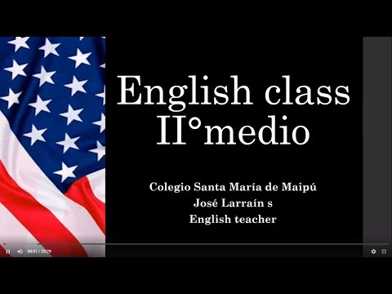
II.-RE-WRITE THE RULES FOR THE FOLLOWINGQUANTIDIERS USING YOUR OWN WORDS.

III.-COMPLETE THE SENTENCES USING A – AN - ANY – SOME.

IV.-COMPLETE THE SENTENCES USING MUCH – MANY – A LOT OF.

*note: you can find out the right answers in the link provided in the instructions.

CONTACT INFO: ingles.ii.smm@gmail.com

