GUIA DE AUTOAPRENDIZAJE Nº12 INGLÉS
IVº MEDIO

Nombre_______________________________________ Curso:_______ Fecha: _______
En esta guía el estudiante estará practicando las habilidades que el idioma inglés requiere para mantener una continuidad en su proceso de aprendizaje.

I.- WATCH THE FOLLOWING VIDEO AND USE YOUR NOTEBOOK WHEN YOU ARE TOLD TO.
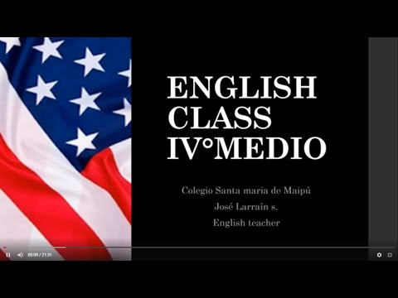
(CLICK ON THE IMAGE BELOW AND THE VIDEO WILL PLAY AUTOMATICALLY)
- DON’T FORGET TO COMPLETE THE ACTIVITIES PROVIDED ON THE VIDEO ABOVE, USE YOUR NOTEBOOK TO KEEP RECORDS OF THEM.

II.-COMPLETE THESE SENTENCES WITH THE PROPER QUESTION TAG.
1.- She's Italian, ___________?
2.- They live in London, ___________?
3.- We're working tomorrow, ___________?
4.- It was cold yesterday, ___________?
5.- He went to the party last night, ___________?
6.- We were waiting at the station, ___________?
7.- She doesn't have any children, _____________?
8.- The bus isn't coming, _____________?
9.- She wasn't at home yesterday, _____________?
10.- They didn't go out last Sunday, _____________?
11.- You weren't sleeping, _____________?

*note: you can find out the right answers in the link provided in the instructions.

CONTACT INFO: ING.CUARTOMEDIO.SMM@GMAIL.COM

