Guía de autoaprendizaje Inglés 3° Básico

NAME:_...................................................................................................................... 3°Básico…………..
Objetivo de aprendizaje:
OA2: Reconocen palabras y expresiones relacionadas con la vestimenta y sus características.
OA6: Identifican información explícita en los textos leídos, como nombres de animales, acciones que desarrollan, etc.
Instrucciones:
-Observar el video de la plataforma de youtube sobre los contenidos de esta semana.
-Con la ayuda de un adulto, realizar esta guía en un lugar tranquilo y con todos tus materiales (estuche, cuaderno).
YOU CAN DO IT!

I.-

I.- Read and select the correct answer.
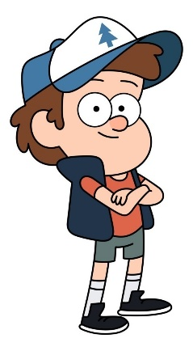
He is wearing……
A) Orange T-shirt and blue jeans
B) Orange T-shirt and blue shorts
C) Yellow jacket and blue shorts

She is wearing……
A) An orange dress
B) A pink dress
C) A yellow dress and jacket

II.- Read the sentence and complete with the use of can or can´t
- The parrot ______________ fly
- The monkey _______________climb
- The Fish________________run

III.- Read the description and select the correct answer.
It´s yellow and blue
It can swim and It can´t climb. It has got 1 tail.
It has go
A) Parrot
B) Fish
C) Tortoise

It´s green
It can swim and It can´t talk. It has got 1 long tail.
It has go
A) Crocodile
B) Fish
C) Monkey

