Guía de autoaprendizaje Inglés 2° Básico

NAME:_...................................................................................................................... 2°Básico…………..
Objetivo de aprendizaje:
OA3: Identifican vocabulario escuchado de partes de la casa y objetos.
OA6: Leen y comprenden descripción de animales.
Instrucciones:
-Observar el video de la plataforma de youtube sobre los contenidos de esta semana.
-Con la ayuda de un adulto, realizar esta guía en un lugar tranquilo y con todos tus materiales (estuche, cuaderno).
YOU CAN DO IT!

I.-

I.- Read the sentence and complete with the use of can or can´t
- The elephant ______________ run
- The monkey _______________climb
- The giraffe________________talk

II.- Read the descrptions and select the correct option.
I´m yellow and brown. I can run but I can´t fly
- Monkey
- Giraffe
- Lion

I´m White and black. I can run but I can´t climb

- Elephant
- Giraffe
- Zebra

III.- Re order with the correct Word.
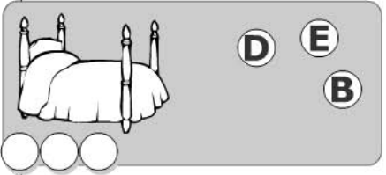

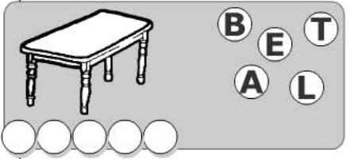

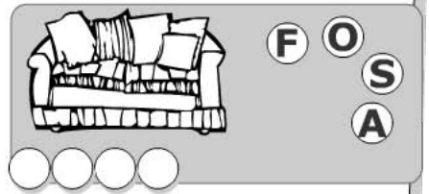

IV,. Circle the correct answer.
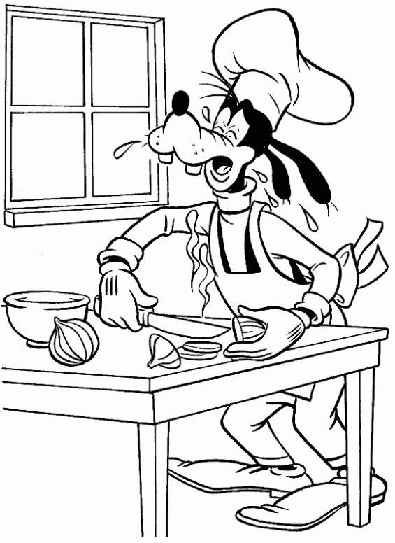  a)Living room  b)Bathroom  c) Kitchen | 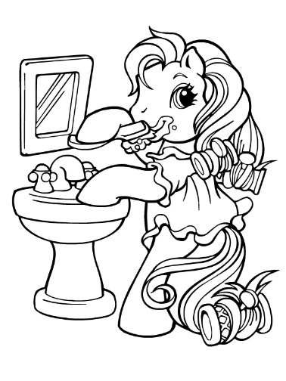  a) Bedroom  b)Bathroom  c)Garden

