GUIA Nº12 INGLÉS
5° GRADE

NAME: ______________________________________ DATE:____________________
Objetivo de Aprendizaje: Expresión oral OA12. Expresión escrita OA14.
- El estudiante logrará expresar cantidad usando números y “A/AN”
Instrucciones:
- Mira el video con los contenidos de la semana en YouTube. El enlace al video está en tu agenda semanal.
- Completa las actividades a medida que el video te lo indique.
- Completa el quiz al final de la guía. Si tienes internet puedes realizarlo en Google Forms. El enlace al quiz está en tu agenda semanal.

Expressing quantity: NUMBERS
Expresando cantidad: NÚMEROS.

- We can express quantity using numbers.
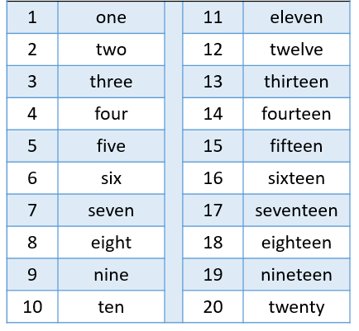
- Podemos expresas cantidad usando los números.
Expressing quantity: A/AN
Expresando cantidad: A/AN.
- We use “a / an” to replace the word one.
- Usamos “a / an” para reemplazar la palabra uno.

- We use “an” when the next word starts with a vowel.
AN
- Usamos “an” cuando la siguiente palabra empieza con una vocal.

- We use “a” when the next word starts with a consonant.
A
- Usamos “a” cuando la siguiente palabra empieza con una consonante.

Activities. Actividades.
- Read the problems and write the correct number. Lee los problemas y escribe el numero correcto.
- I have got eight donuts and fifteen strawberries. My sister gave me three donuts and one strawberry. How many donuts have I got?
  - She has got _________________ donuts.
- The monkey has got twenty bananas. It ate two bananas. How many bananas has it got?
  - It has got _________________ bananas.
- They have got four lettuces and seventeen tomatoes. They ate two tomatoes and one lettuce in a salad. How many tomatoes have they got?
  - They have got _________________ tomatoes.
- The cat has got five fish. It found seven fish more. How many fish has the cat got?
  - It has got _________________ fish.

- Look at the picture A, AN or X. Mira la imagen y escribe A, AN o X.
Quiz N°7
- Look at the picture, count and choose the correct number. Mira la imagen, cuenta y escoge el numero correcto.

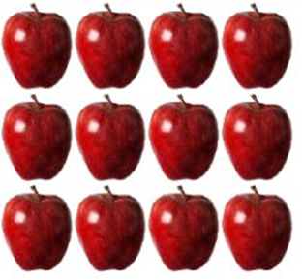  1)  - Twenty  - Twelve  - Two  - Eleven | 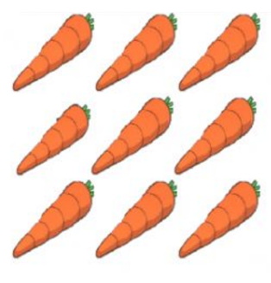  2)  - Eight  - Eighteen  - Nine  - Nineteen
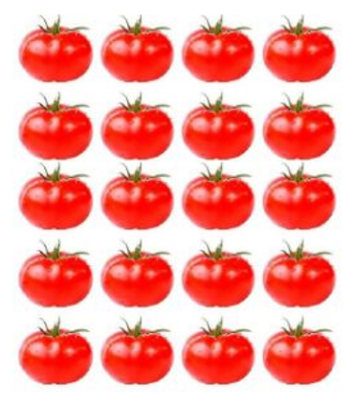  3)  - Sixteen  - Eighteen  - Twelve  - Twenty | 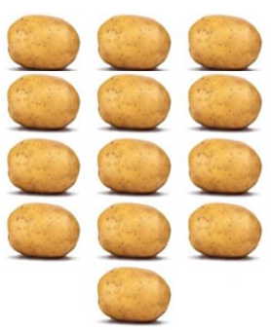  4)  - Twelve  - Thirteen  - Fourteen  - Fifteen
- Complete the sentences with A, AN or X. Completa la oración con A, AN o X. (la x es en caso de que no sea necesario usar a o an).

- I have got ______ hamburgers.  - A  - AN  - X | - I have got ______ lettuce.  - A  - AN  - X
- I have got ______ onion.

- A
- AN
- X

